Python

Chapter 2. Data: Types, Values, Variables, and Names

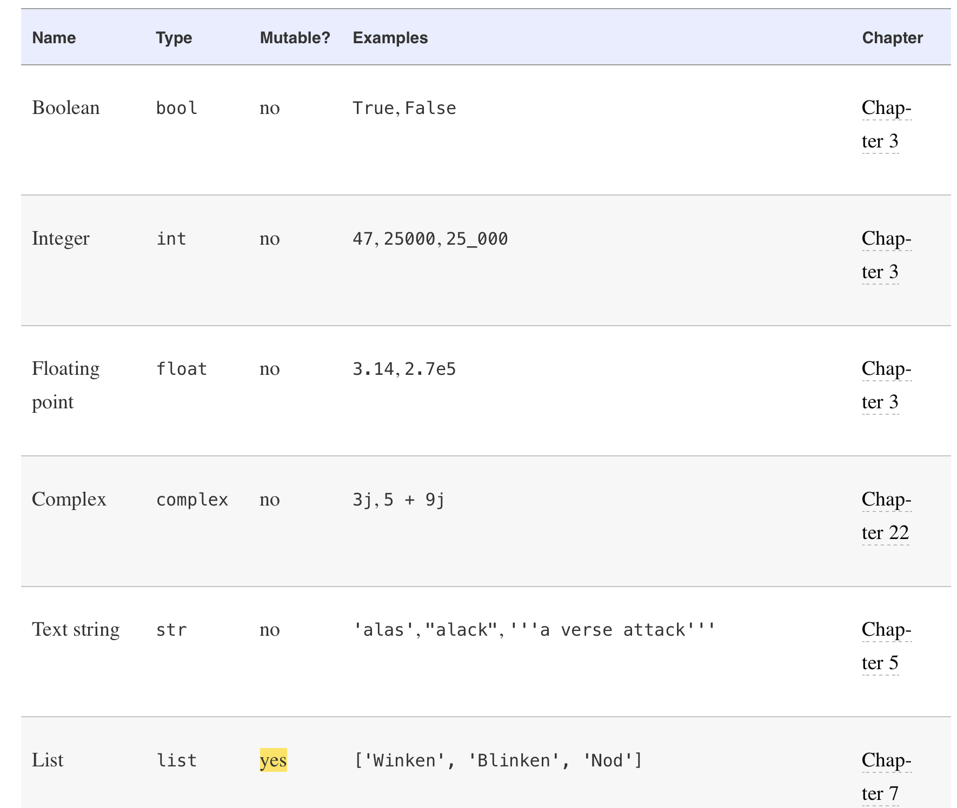

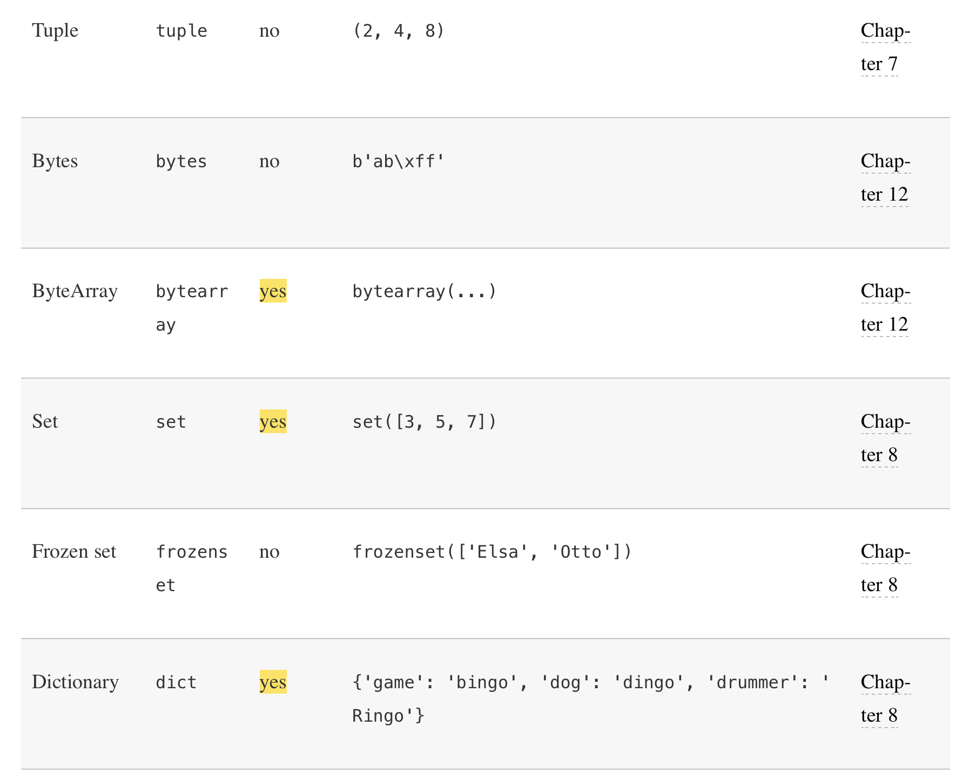
Mutable ==> value can be changed

Immutable ==> value cannot be changed. You can't add, remove, or replace any elements, once you declare it ,you are done
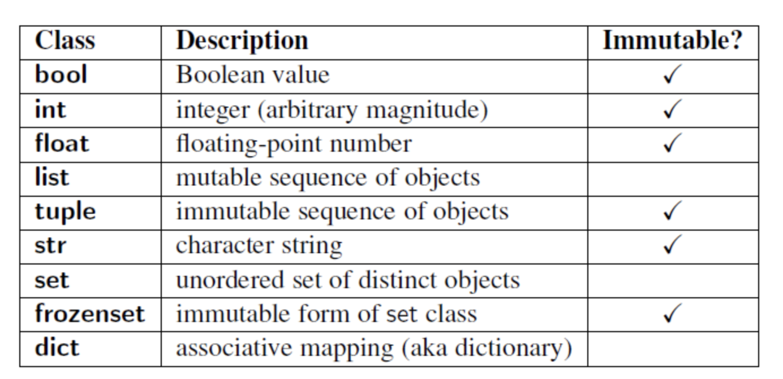
List | Tuple | Set | Remarks
Mutable | Immutable | Mutable
Can contain dups | Can contain dups | a array of unique elements
store values in a sequence | store values in a sequence | Doesn’t store values in a sequence.
 |  | Faster than list, tuple
Hashable | Hashable | Elements of a set is not hashable i.e cannot be looked up by index
Takes little more memory than Tuple | Takes less memory than list
Elements in the set can be of different types | Elements in the set can be of different types | Elements in the set can be of different types

Diff between List and Tuple:

https://www.afternerd.com/blog/difference-between-list-tuple/

Python is strongly typed, which means that the type of an object does not change, even if its value is mutable

variables—names for values in your computer’s memory that you want to use in a program. They are case-sensitive.

>>> help("keywords")

type(thing)

isinstance(type)

Chapter 3. Numbers

The special Python function bool() can convert any Python data type to a boolean.

Here’s how to get both the (truncated) quotient and remainder at once:

>>> divmod(9,5)

The chr() function converts an integer to its single-character string equivalent:

And ord() goes the other way.

To change other Python data types to an integer, use the int() function.

int() will make integers from floats or strings of digits, but it won’t handle strings containing decimal points or exponents

Chapter 4. Choose with if

if, elif, and else

>>> color = "mauve"
>>> if color == "red":
... print("It's a tomato")
... elif color == "green":
... print("It's a green pepper")
... elif color == "bee purple":
... print("I don't know what it is, but only bees can see it")
... else:
... print("I've never heard of the color", color)

Whenever you need to make a lot of comparisons like that, separated by or, use Python’s membership operator in, instead
if letter in vowels:
... print(letter, 'is a vowel')

Chapter 5. Text Strings

You make a Python string by enclosing characters in matching single or double quotes.
You can have single quotes inside double-quoted strings, or double quotes inside single-quoted strings.
You can also use three single quotes (''') or three double quotes ("""). Common use is to create multiline strings.
print() strips quotes from strings and prints their contents.
You can make a string from another data type by using the str() function
By preceding a character with a backslash (\), Python lets you escape the meaning of some characters within strings .
\n, \t etc

Combine by Using +
Duplicate with *
Get a Character with []

replace()
>>> name = 'Henny'
>>> name.replace('H', 'P')
'Penny'

Get a Substring with a Slice

- [:] extracts the entire sequence from start to end.
- [ start :] specifies from the start offset to the end.
- [: end ] specifies from the beginning to the end offset minus 1.
- [ start : end ] indicates from the start offset to the end offset minus 1.
- [ start : end : step ] extracts from the start offset to the end offset minus 1, skipping characters by step.

offsets go 0, 1, and so on from the start to the right, and –1,–2, and so forth from the end to the left.
A slice offset earlier than the beginning of a string is treated as 0, and one after the end is treated as -1

Get Length with len()

To use a string function, type the name of the string, a dot, the name of the function, and any arguments that the function needs: string.function(arguments).

Split with split()

If you don’t specify a separator, split() uses any sequence of white space characters—newlines, spaces, and tabs:

Combine by Using join()

Substitute by Using replace()

Strip with strip()
strip() strips both ends, lstrip() only from the left, and rstrip()only from the right.

Search and Select
>>> poem.startswith('All')
>>> poem.endswith('That\'s all, folks!')

Python has two methods (find() and index()) for finding the offset of a substring, and has two versions of each (starting from the beginning or the end). They work the same if the substring is found. If it isn’t, find()returns -1, and index() raises an exception.

How many times does the three-letter sequence the occur?
>>> poem.count(word)

Are all of the characters in the poem either letters or numbers?
>>> poem.isalnum()

Case
Capitalize the first word:
>>> setup.capitalize()

Capitalize all the words:
>>> setup.title()

Convert all characters to uppercase:
>>> setup.upper()

Convert all characters to lowercase:
>>> setup.lower()

Swap uppercase and lowercase:
>>> setup.swapcase()

Alignment:
>>> setup.center(30)

>>> setup.ljust(30)

>>> setup.rjust(30)

Formatting:
>>> '%s' % 42
'42'
>>> '%d' % 42
'42'
>>> '%x' % 42
'2a'
>>> '%o' % 42
'52'

Let’s try some string and integer interpolation:
>>> actor = 'Richard Gere'
>>> cat = 'Chester'
>>> weight = 28
>>> "My wife's favorite actor is %s" % actor
"My wife's favorite actor is Richard Gere"
>>> "Our cat %s weighs %s pounds" % (cat, weight)
'Our cat Chester weighs 28 pounds'
That %s inside the string means to interpolate a string. The number of % appearances in the string needs to match the number of data items after the % that follows the string.

New style: {} and format()

>>> thing = 'woodchuck'
>>> '{}'.format(thing)
'woodchuck'
>>> thing = 'woodchuck'
>>> place = 'lake'
>>> 'The {} is in the {}.'.format(thing, place)
'The woodchuck is in the lake.'
>>> 'The {1} is in the {0}.'.format(place, thing)
'The woodchuck is in the lake.'
>>> 'The {thing} is in the {place}'.format(thing='duck', place='bathtub')
'The duck is in the bathtub'

Chapter 6. Loop with while and for

Repeat with while
>>> count = 1
>>> while count <= 5:
... print(count)
... count += 1

Cancel with break
>>> while True:
... stuff = input("String to capitalize [type q to quit]: ")
... if stuff == "q":
... break
... print(stuff.capitalize())

Skip Ahead with continue
>>> while True:
... value = input("Integer, please [q to quit]: ")
... if value == 'q': # quit
... break
... number = int(value)
... if number % 2 == 0: # an even number
... continue
... print(number, "squared is", number*number)

Check break Use with else
If the while loop ended normally (no break call), control passes to an optional else.
>>> numbers = [1, 3, 5]
>>> position = 0
>>> while position < len(numbers):
... number = numbers[position]
... if number % 2 == 0:
... print('Found even number', number)
... break
... position += 1
... else: # break not called
... print('No even number found')

Iterate with for and in
>>> for letter in word:
... print(letter)

Cancel with break
>>> word = 'thud'
>>> for letter in word:
... if letter == 'u':
... break
... print(letter)

Skip with continue

Check break Use with else
>>> word = 'thud'
>>> for letter in word:
... if letter == 'x':
... print("Eek! An 'x'!")
... break
... print(letter)
... else:
... print("No 'x' in there.")

Generate Number Sequences with range()
range( start, stop, step ). If you omit start, the range begins at 0.
Mandatory value is stop
The default value of step is 1
>>> for x in range(0,3):
... print(x)

Chapter 7. Tuples and Lists

Tuples

Create with Commas and ()
>>> one_marx = ('Groucho',)
>>> marx_tuple = ('Groucho', 'Chico', 'Harpo')
Tuples let you assign multiple variables at once:
>>> marx_tuple = ('Groucho', 'Chico', 'Harpo')
>>> a, b, c = marx_tuple
This is sometimes called tuple unpacking.

Create with tuple()
The tuple() conversion function makes tuples from other things:
>>> marx_list = ['Groucho', 'Chico', 'Harpo']
>>> tuple(marx_list)

Combine Tuples by Using +

Duplicate Items with *

Compare Tuples

Iterate with for and in

Modify a Tuple: You can’t! Like strings, tuples are immutable, so you can’t change an existing one.

Lists:
The same value can occur more than once in a list.

Create with []
>>> empty_list = [ ]
>>> weekdays = ['Monday', 'Tuesday', 'Wednesday', 'Thursday', 'Friday']

Create or Convert with list()
>>> another_empty_list = list()
>>> another_empty_list
[]

>>> list('cat')
['c', 'a', 't']

>>> a_tuple = ('ready', 'fire', 'aim')
>>> list(a_tuple)
['ready', 'fire', 'aim']

Create from a String with split()
>>> talk_like_a_pirate_day = '9/19/2019'
>>> talk_like_a_pirate_day.split('/')
['9', '19', '2019']

Get an Item by [ offset ]
The offset has to be a valid one for this list.

Get Items with a Slice
>>> marxes = ['Groucho', 'Chico', 'Harpo']
>>> marxes[0:2]
['Groucho', 'Chico']
A slice of a list is also a list.
list.reverse()
As you saw with strings, a slice can specify an invalid index, but will not cause an exception. It will “snap” to the closest valid index or return nothing:
>>> marxes = ['Groucho', 'Chico', 'Harpo']
>>> marxes[4:]
[]
>>> marxes[-6:]
['Groucho', 'Chico', 'Harpo']
>>> marxes[-6:-2]
['Groucho']
>>> marxes[-6:-4]
[]

Add an Item to the End with append()
>>> marxes = ['Groucho', 'Chico', 'Harpo']
>>> marxes.append('Zeppo')
>>> marxes

Add an Item by Offset with insert()
>>> marxes = ['Groucho', 'Chico', 'Harpo']
>>> marxes.insert(2, 'Gummo')
>>> marxes
['Groucho', 'Chico', 'Gummo', 'Harpo']

Duplicate All Items with *

Combine Lists by Using extend() or +
>>> marxes = ['Groucho', 'Chico', 'Harpo', 'Zeppo']
>>> others = ['Gummo', 'Karl']
>>> marxes.extend(others)
>>> marxes
['Groucho', 'Chico', 'Harpo', 'Zeppo', 'Gummo', 'Karl']

Alternatively, you can use + or +=:
>>> marxes = ['Groucho', 'Chico', 'Harpo', 'Zeppo']
>>> others = ['Gummo', 'Karl']
>>> marxes += others
>>> marxes
['Groucho', 'Chico', 'Harpo', 'Zeppo', 'Gummo', 'Karl']

Change an Item by [ offset ]
>>> marxes = ['Groucho', 'Chico', 'Harpo']
>>> marxes[2] = 'Wanda'
>>> marxes
['Groucho', 'Chico', 'Wanda']

Change Items with a Slice
>>> numbers = [1, 2, 3, 4]
>>> numbers[1:3] = [8, 9]
>>> numbers
[1, 8, 9, 4]

Delete an Item by Offset with del
>>> marxes = ['Groucho', 'Chico', 'Harpo', 'Gummo', 'Karl']
>>> marxes[-1]
'Karl'
>>> del marxes[-1]
>>> marxes
['Groucho', 'Chico', 'Harpo', 'Gummo']

Delete an Item by Value with remove()
>>> marxes = ['Groucho', 'Chico', 'Harpo']
>>> marxes.remove('Groucho')
>>> marxes
['Chico', 'Harpo']

Get an Item by Offset and Delete It with pop()
If you call pop()with an offset, it will return the item at that offset; with no argument, it uses -1. So, pop(0) returns the head (start) of the list, and pop() or pop(-1) returns the tail (end)
>>> marxes = ['Groucho', 'Chico', 'Harpo', 'Zeppo']
>>> marxes.pop()
'Zeppo'
>>> marxes
['Groucho', 'Chico', 'Harpo']

>>> marxes.pop(1)
'Chico'
>>> marxes
['Groucho', 'Harpo']

Delete All Items with clear()
>>> work_quotes = ['Working hard?', 'Quick question!', 'Number one priorities!']
>>> work_quotes
['Working hard?', 'Quick question!', 'Number one priorities!']
>>> work_quotes.clear()
>>> work_quotes
[]

Find an Item’s Offset by Value with index()
>>> marxes = ['Groucho', 'Chico', 'Harpo', 'Zeppo']
>>> marxes.index('Chico')
1
If the value is in the list more than once, only the offset of the first one is returned.

Test for a Value with in
>>> marxes = ['Groucho', 'Chico', 'Harpo', 'Zeppo']
>>> 'Groucho' in marxes
True
>>> 'Bob' in marxes
False
>>> words = ['a', 'deer', 'a' 'female', 'deer']
>>> 'deer' in words
True

Count Occurrences of a Value with count()
>>> marxes = ['Groucho', 'Chico', 'Harpo']
>>> marxes.count('Harpo')
1

Convert a List to a String with join()
>>> marxes = ['Groucho', 'Chico', 'Harpo']
>>> ', '.join(marxes)
'Groucho, Chico, Harpo'

>>> friends = ['Harry', 'Hermione', 'Ron']
>>> separator = ' * '
>>> joined = separator.join(friends)
>>> joined
'Harry * Hermione * Ron'

Reorder Items with sort() or sorted()

The list method sort() sorts the list itself, in place.
The general function sorted() returns a sorted copy of the list.
>>> marxes = ['Groucho', 'Chico', 'Harpo']
>>> sorted_marxes = sorted(marxes)
>>> sorted_marxes
['Chico', 'Groucho', 'Harpo']

>>> numbers = [2, 1, 4.0, 3]
>>> numbers.sort()
>>> numbers
[1, 2, 3, 4.0]

Get Length with len()
>>> marxes = ['Groucho', 'Chico', 'Harpo']
>>> len(marxes)
3

Assign with =
>>> a = [1, 2, 3]
>>> a
[1, 2, 3]
>>> b = a
>>> b
[1, 2, 3]
>>> a[0] = 'surprise'
>>> a
['surprise', 2, 3]

Copy with copy(), list(), or a Slice
You can copy the values of a list to an independent, fresh list by using any of these methods:
>>> a = [1, 2, 3]
>>> b = a.copy()
>>> c = list(a)
>>> d = a[:]

Copy Everything with deepcopy()
>>> a = [1, 2, [8, 9]]
>>> b = a.copy()
>>> c = list(a)
>>> d = a[:]
>>> a
[1, 2, [8, 9]]
>>> b
[1, 2, [8, 9]]
>>> c
[1, 2, [8, 9]]
>>> d
[1, 2, [8, 9]]
>>> import copy
>>> a = [1, 2, [8, 9]]
>>> b = copy.deepcopy(a)
>>> a
[1, 2, [8, 9]]
>>> b
[1, 2, [8, 9]]
>>> a[2][1] = 10
>>> a
[1, 2, [8, 10]]
>>> b
[1, 2, [8, 9]]

Compare Lists
>>> a = [7, 2]
>>> b = [7, 2, 9]
>>> a == b
False
>>> a <= b
True
>>> a < b
True

Iterate with for and in
>>> cheeses = ['brie', 'gjetost', 'havarti']
>>> for i in cheeses:
... print(i)

Iterate Multiple Sequences with zip()
iterating over multiple sequences in parallel by using the zip() function:

>>> days = ['Monday', 'Tuesday', 'Wednesday']
>>> fruits = ['banana', 'orange', 'peach']
>>> drinks = ['coffee', 'tea', 'beer']
>>> desserts = ['tiramisu', 'ice cream', 'pie', 'pudding']
>>> for day, fruit, drink, dessert in zip(days, fruits, drinks, desserts):
... print(day, ": drink", drink, "- eat", fruit, "- enjoy", dessert)
Monday : drink coffee - eat banana - enjoy tiramisu
Tuesday : drink tea - eat orange - enjoy ice cream
Wednesday : drink beer - eat peach - enjoy pie
zip() stops when the shortest sequence is done.

Create a List with a Comprehension
>>> number_list = []
>>> for i in range(1, 6):
... number_list.append(i)
...
>>> number_list
[1, 2, 3, 4, 5]
>>> number_list = [i for i in range(1,6)]
>>> number_list
[1, 2, 3, 4, 5]

Lists of Lists
>>> small_birds = ['hummingbird', 'finch']
>>> extinct_birds = ['dodo', 'passenger pigeon', 'Norwegian Blue']
>>> carol_birds = [3, 'French hens', 2, 'turtledoves']
>>> all_birds = [small_birds, extinct_birds, 'macaw', carol_birds]
>>> all_birds
[['hummingbird', 'finch'], ['dodo', 'passenger pigeon', 'Norwegian Blue'], 'macaw',
[3, 'French hens', 2, 'turtledoves']]
>>> all_birds[1][0]
'dodo'

Chapter 8. Dictionaries and Sets

You specify a unique key to associate with each value. Remember that dictionary keys must be unique.
If you use a key more than once, the last value wins.

Create with {}
>>> empty_dict = {}
>>> empty_dict
{}
>>> bierce = {
... "day": "A period of twenty-four hours, mostly misspent",
... "positive": "Mistaken at the top of one's voice",
... "misfortune": "The kind of fortune that never misses",
... }

Convert with dict()

>>> lol = [ ['a', 'b'], ['c', 'd'], ['e', 'f'] ]
>>> dict(lol)
{'a': 'b', 'c': 'd', 'e': 'f'}
>>> lot = [ ('a', 'b'), ('c', 'd'), ('e', 'f') ]
>>> dict(lot)
{'a': 'b', 'c': 'd', 'e': 'f'}

Add or Change an Item by [ key ]

>>> pythons = {
... 'Chapman': 'Graham',
... 'Cleese': 'John',
... 'Idle': 'Eric',
... 'Jones': 'Terry',
... 'Palin': 'Michael',
... }
>>> pythons
{'Chapman': 'Graham', 'Cleese': 'John', 'Idle': 'Eric',
'Jones': 'Terry', 'Palin': 'Michael'}
>>> pythons['Gilliam'] = 'Gerry'
>>> pythons
{'Chapman': 'Graham', 'Cleese': 'John', 'Idle': 'Eric',
'Jones': 'Terry', 'Palin': 'Michael', 'Gilliam': 'Gerry'}

Get an Item by [key] or with get()

>>> some_pythons['John']
'Cleese'
>>> some_pythons.get('John')
'Cleese'

Get All Keys with keys()
>>> signals = {'green': 'go', 'yellow': 'go faster', 'red': 'smile for the camera'}
>>> signals.keys()
dict_keys(['green', 'yellow', 'red'])

Get All Values with values()
>>> list( signals.values() )
['go', 'go faster', 'smile for the camera']

Get All Key-Value Pairs with items()
>>> list( signals.items() )
[('green', 'go'), ('yellow', 'go faster'), ('red', 'smile for the camera')]

Get Length with len()
>>> len(signals)
3

Combine Dictionaries with {**a, **b}
>>> first = {'a': 'agony', 'b': 'bliss'}
>>> second = {'b': 'bagels', 'c': 'candy'}
>>> {**first, **second}
{'a': 'agony', 'b': 'bagels', 'c': 'candy'}

Combine Dictionaries with update()
>>> others = { 'Marx': 'Groucho', 'Howard': 'Moe' }

>>> pythons.update(others)

Delete an Item by Key with del
>>> del pythons['Marx']

Get an Item by Key and Delete It with pop()
>>> pythons.pop('Palin')
'Michael'

Delete All Items with clear()
>>> pythons.clear()

Test for a Key with in
>>> 'Chapman' in pythons

Assign with =
>>> signals = {'green': 'go',
... 'yellow': 'go faster',
... 'red': 'smile for the camera'}
>>> save_signals = signals

Copy with copy()
>>> original_signals = signals.copy()

Copy Everything with deepcopy()
>>> import copy
>>> signals_copy = copy.deepcopy(signals)

Compare Dictionaries
>>> a = {1:1, 2:2, 3:3}
>>> b = {3:3, 1:1, 2:2}
>>> a == b
True

Iterate with for and in
>>> for card in accusation: # or, for card in accusation.keys():
... print(card)

>>> for value in accusation.values():

>>> for item in accusation.items():

>>> for card, contents in accusation.items():

Dictionary Comprehensions
>>> word = 'letters'
>>> letter_counts = {i: word.count(i) for i in word}
>>> letter_counts
{'l': 1, 'e': 2, 't': 2, 'r': 1, 's': 1}
{key_expression : value_expression for expression in iterable if condition}

Sets
As with a dictionary, each key must be unique. Sets are unordered.

Create with set()

>>> empty_set = set()
>>> empty_set
set()
>>> even_numbers = {0, 2, 4, 6, 8}
>>> even_numbers

Convert with set()
>>> set( 'letters' )
{'l', 'r', 's', 't', 'e'}
>>> set( ['Dasher', 'Dancer', 'Prancer', 'Mason-Dixon'] )
{'Dancer', 'Dasher', 'Mason-Dixon', 'Prancer'}
>>> set( ('Ummagumma', 'Echoes', 'Atom Heart Mother') )
{'Ummagumma', 'Atom Heart Mother', 'Echoes'}

Get Length with len()
>>> reindeer = set( ['Dasher', 'Dancer', 'Prancer', 'Mason-Dixon'] )
>>> len(reindeer)
4

Add an Item with add()
>>> s = set((1,2,3))
>>> s
{1, 2, 3}
>>> s.add(4)
>>> s
{1, 2, 3, 4}

Delete an Item with remove()
>>> s = set((1,2,3))
>>> s.remove(3)
>>> s
{1, 2}

Iterate with for and in
>>> furniture = set(('sofa', 'ottoman', 'table'))
>>> for piece in furniture:
... print(piece)

Test for a Value with in
>>> drinks = {
... 'martini': {'vodka', 'vermouth'},
... 'black russian': {'vodka', 'kahlua'},
... 'white russian': {'cream', 'kahlua', 'vodka'},
... 'manhattan': {'rye', 'vermouth', 'bitters'},
... 'screwdriver': {'orange juice', 'vodka'}
... }
>>> for name, contents in drinks.items():
... if 'vodka' in contents:
... print(name)
if 'vodka' in contents and not ('vermouth' in contents or
... 'cream' in contents):

Combinations and Operators:

if contents & {'vermouth', 'orange juice'}:

if 'vodka' in contents and not contents & {'vermouth', 'cream'}:

>>> a = {1, 2}
>>> b = {2, 3}

>>> a & b
or
>>> a.intersection(b)

>>> a | b
{1, 2, 3}
>>> a.union(b)
{1, 2, 3}

>>> a - b
{1}
>>> a.difference(b)
{1}
>>> a ^ b
{1, 3}
>>> a.symmetric_difference(b)
{1, 3}
>>> a <= b
False
>>> a.issubset(b)
False
>>> a <= a
True
>>> a.issubset(a)
True
>>> a >= b
False
>>> a.issuperset(b)
False

Set Comprehensions

{ expression for expression in iterable if condition }

>>> a_set = {i for i in range(1,6) if number % 3 == 1}
>>> a_set
{1, 4}

Create an Immutable Set with frozenset()

>>> frozenset([3, 2, 1])
frozenset({1, 2, 3})
Sample Files:
https://github.com/mwaskom/seaborn-data/find/master

NUMPY ARRAY

To be read from websites.

Numpy creation:

array(object, dtype=None, copy=True, order='K', subok=False, ndmin=0)

Below to be covered from W3 Schools.com
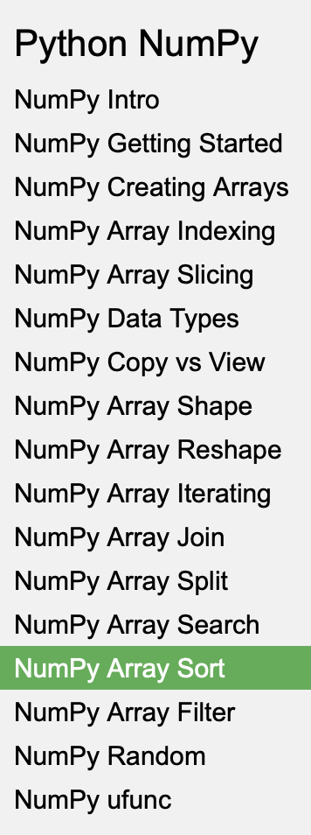

From the book:

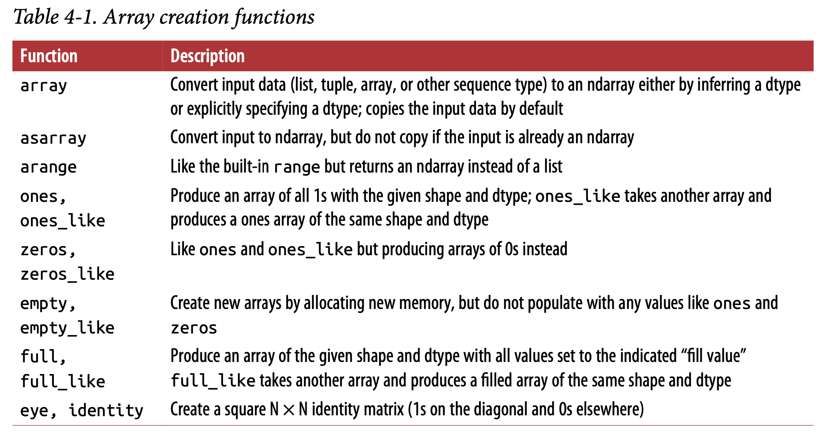
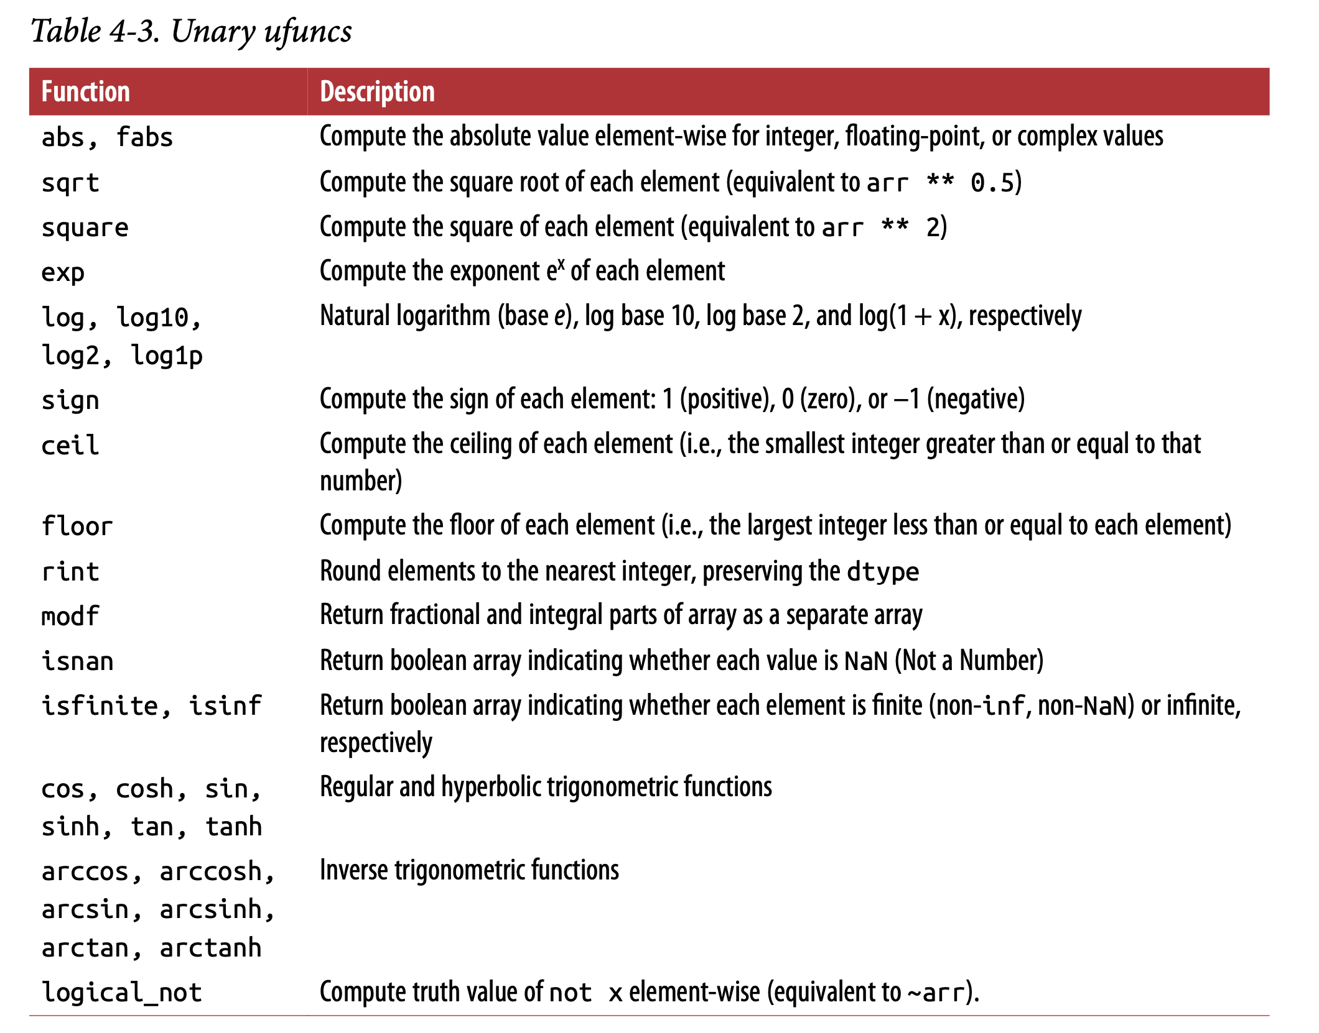

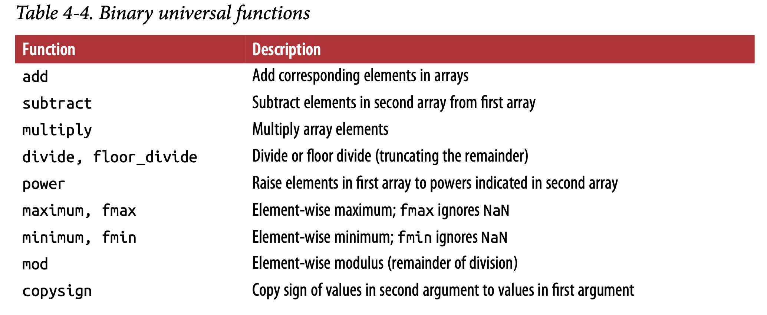
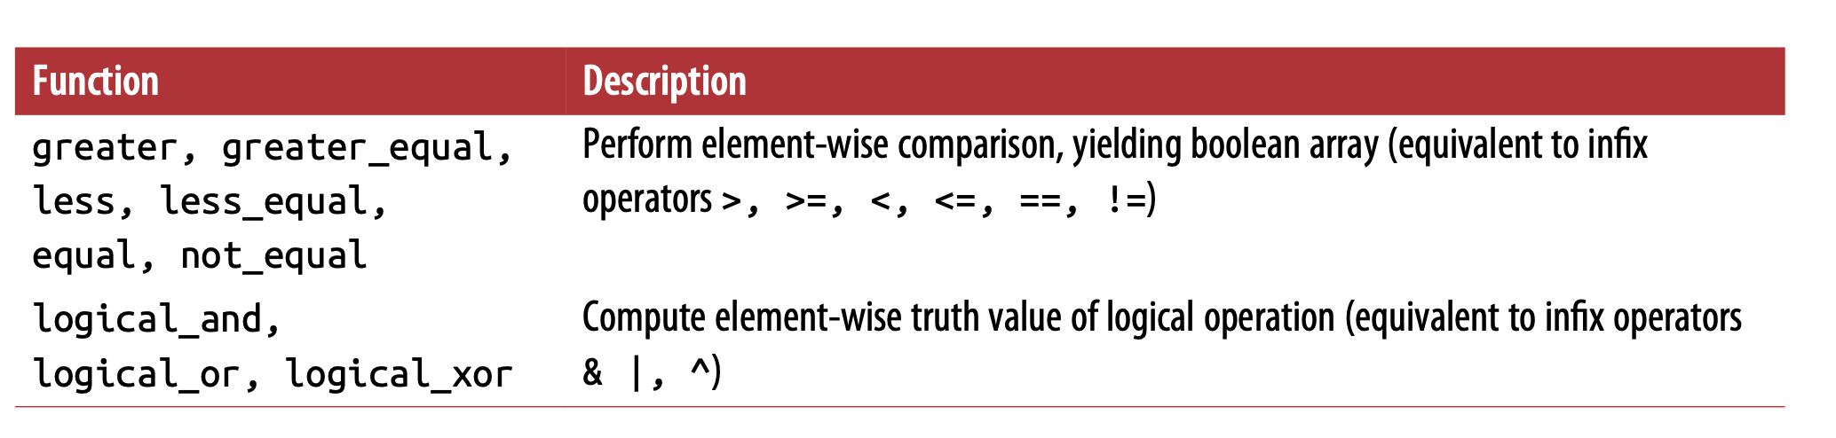
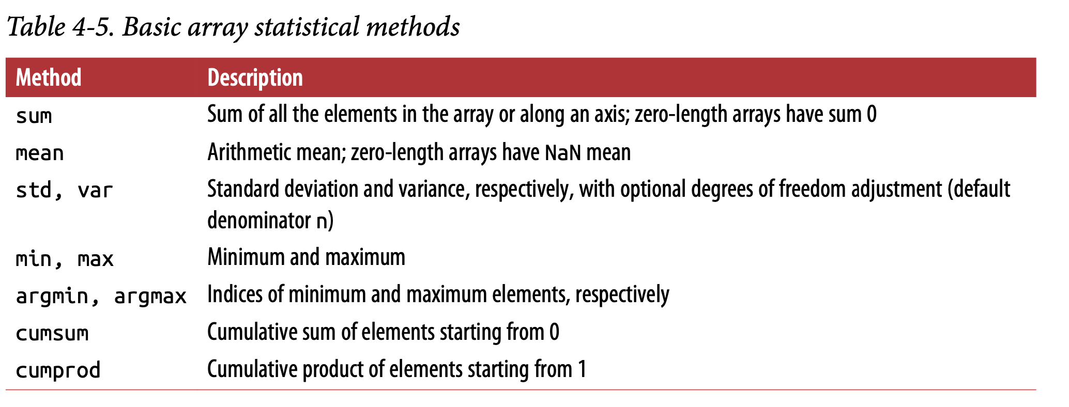

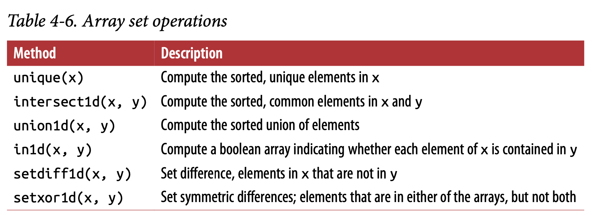

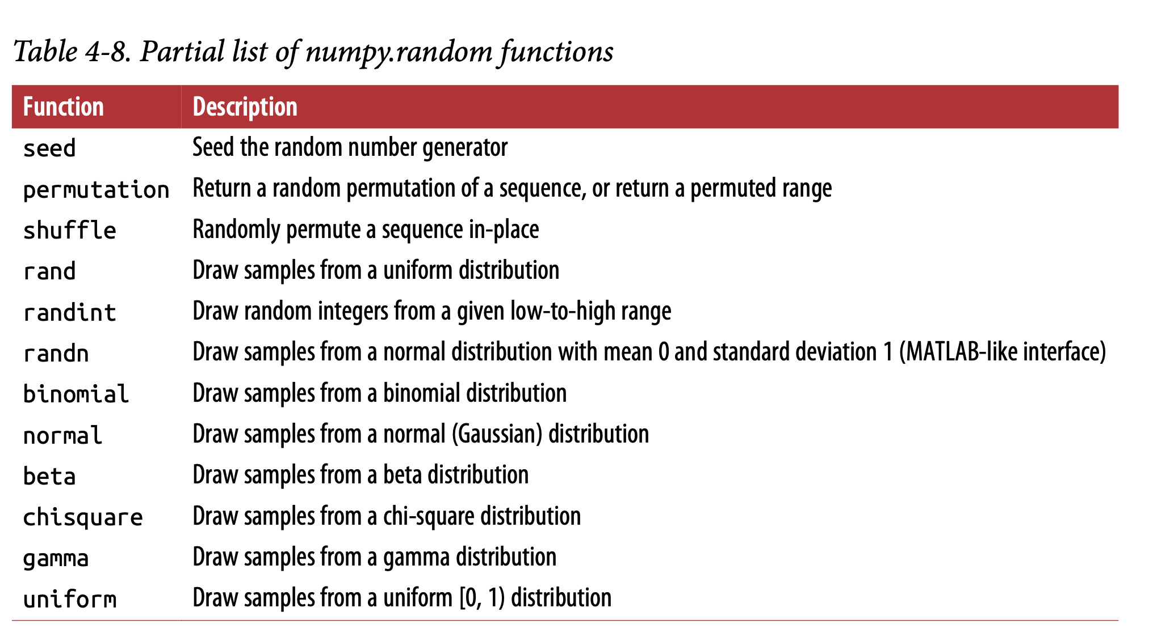

Python for Data Analysis - Wes McKinney

5.1 Introduction to pandas Data Structures
Note: Pandas has it’s own built in methods/functions also, which can be used as functions on series, dataframe objects. Eg: isnull is an pandas function which can be used on series object like pd.isnull(obj1), here obj1 is series object.
Series and Dataframe will have it’s own method/functions too.
Useful link:
https://www.tutorialspoint.com/python_pandas/index.htm

Series :
Creating the Series:
Init signature:
pd.Series(
data=None,
index=None,
dtype=None,
name=None,
copy=False,
fastpath=False,
)
Docstring:
One-dimensional ndarray with axis labels (including time series).

obj = pd.Series([4, 7, -5, 3])
obj.values
obj.index

sdata = {'Ohio': 35000, 'Texas': 71000, 'Oregon': 16000, 'Utah': 5000}
obj3 = pd.Series(sdata)

states = ['California', 'Ohio', 'Oregon', 'Texas']

obj4 = pd.Series(sdata, index=states)

obj2 = pd.Series([4, 7, -5, 3], index=['d', 'b', 'a', 'c'])
Selecting the values:
obj2['a'] ==> selecting single index
obj2[['c', 'a', 'd']] ==> selecting multiple indexes

NumPy-like operations can be performed:
obj2[obj2 > 0]
obj2 * 2

'b' in obj2

Pandas Function on Series:
pd.isnull(obj4)
pd.notnull(obj4)

Series also has these as instance methods:
obj4.isnull()

A Series’s index can be altered in-place by assignment:
obj.index = ['Bob', 'Steve', 'Jeff', 'Ryan']

DataFrame :
pd.DataFrame(
data=None,
index: Union[Collection, NoneType] = None,
columns: Union[Collection, NoneType] = None,
dtype: Union[str, numpy.dtype, ForwardRef('ExtensionDtype'), NoneType] = None,
copy: bool = False,
)

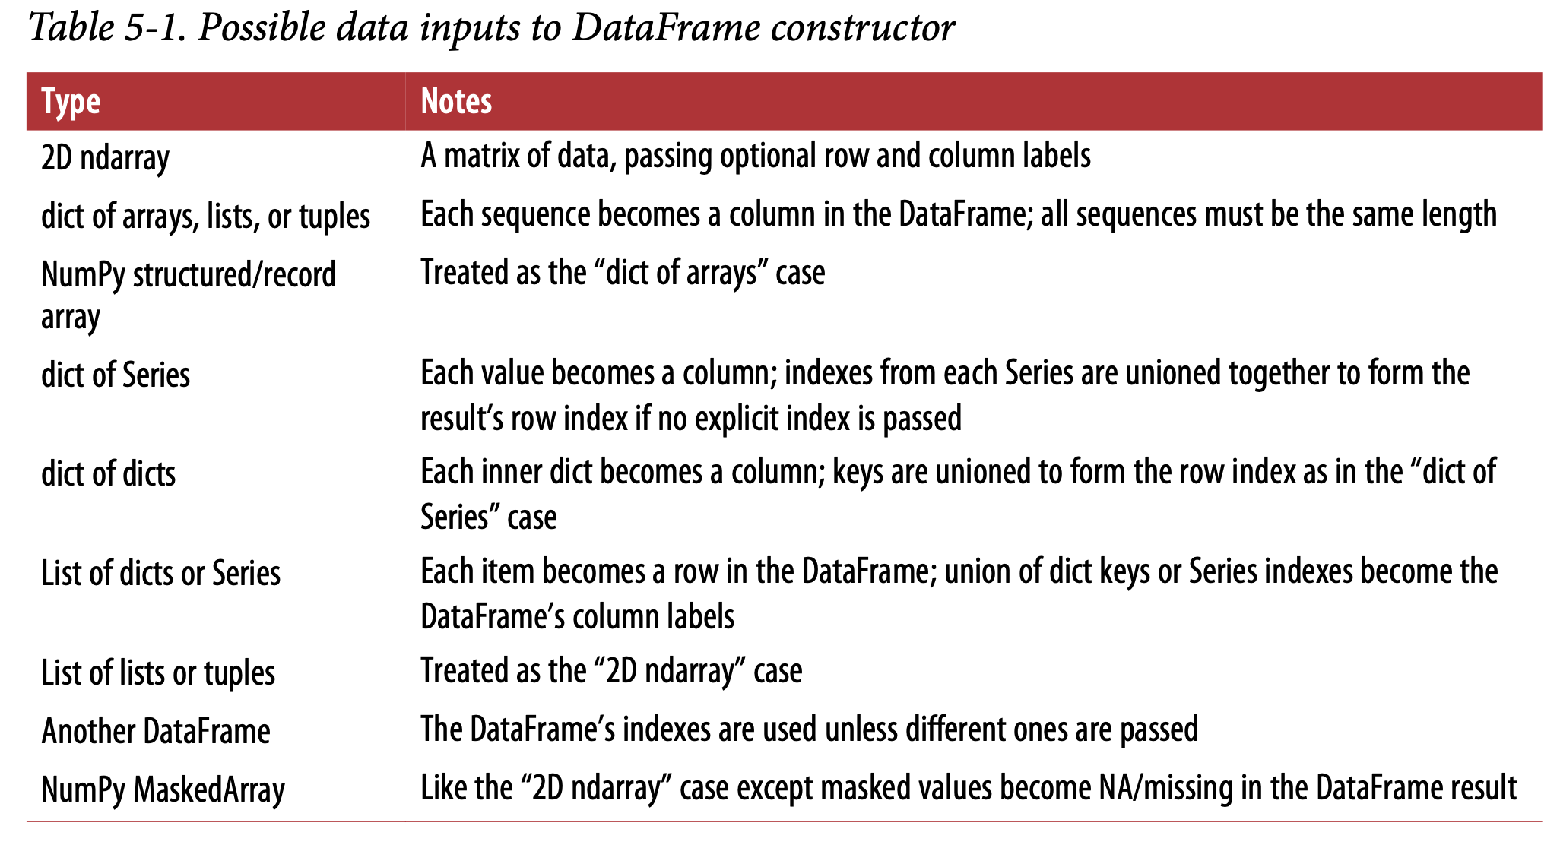
data = {'state': ['Ohio', 'Ohio', 'Ohio', 'Nevada', 'Nevada', 'Nevada'],
'year': [2000, 2001, 2002, 2001, 2002, 2003],
'pop': [1.5, 1.7, 3.6, 2.4, 2.9, 3.2]}
frame = pd.DataFrame(data)
frame = pd.DataFrame(data, columns=['year', 'state', 'pop']) ==> if we want to specify the order of columns.

Fetch sample records:
frame.head()
frame.columns
frame.values
frame.index
index1 = frame.index
index1.values

Fetch the column:
frame2['state'] or frame2.state

Modify column values:

frame2['debt'] = 16.5
frame2['debt'] = np.arange(6.)

Delete a column:

del frame2['eastern']

Index Objects

frame.index
index1 = frame.index
index1.values
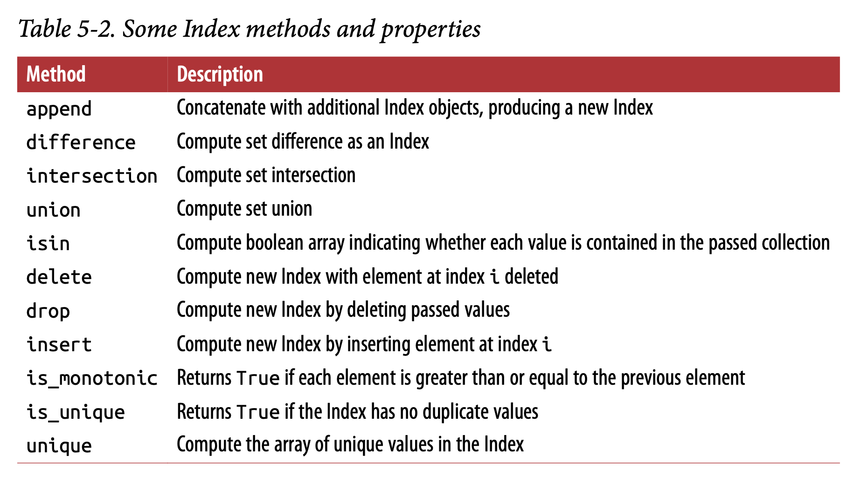

5.2 Essential Functionality
Reindexing
reindex can alter either the (row) index, columns, or both
frame.reindex(['a', 'b', 'c', 'd']) ==> row name/index
frame.reindex(columns=['Texas', 'Utah', 'California']) ==> column names/index

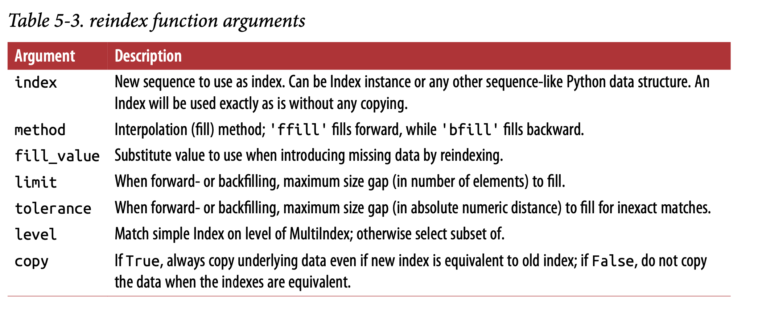
Dropping Entries from an Axis
To drop at row level:
new_obj = obj.drop('c') ==> will not drop from obj, creates new_obj without row ‘c’

obj.drop('c', inplace = True) ==> will modify obj itself.
If we execute,
obj.drop('c') ==> will not drop row ‘c’from obj but shows the result like its dropped, if we apply Inplace = True then ony it will drop/take action.

To drop at column level:
data.drop(['two', 'four'], axis='columns')
or
data.drop('two', axis=1)

Indexing, Selection, and Filtering
Series Indexing:
obj = pd.Series(np.arange(4.), index=['a', 'b', 'c', 'd'])

obj['b']
obj[1]
obj[2:4]
obj[['b', 'a', 'd']]
obj[[1, 3]]
obj[obj < 2]
obj['b':'c']
obj['b':'c'] = 5

DataFrame Indexing:
data = pd.DataFrame(np.arange(16).reshape((4, 4)),
index=['Ohio', 'Colorado', 'Utah', 'New York'],
columns=['one', 'two', 'three', 'four'])
data['two']
data[['three', 'one']]
data[:2]
data[data['three'] > 5]
data < 5
data[data < 5] = 0

Selection with loc and iloc
axis labels (loc) or integers (iloc).

data.loc['Colorado', ['two', 'three']]
data.iloc[2, [3, 0, 1]]
data.iloc[2]
data.iloc[[1, 2], [3, 0, 1]]

Both indexing functions work with slices in addition to single labels or lists of labels (like above):
data.loc[:'Utah', 'two']
data.iloc[:, :3][data.three > 5]
Table 5-4. Indexing options with DataFrame
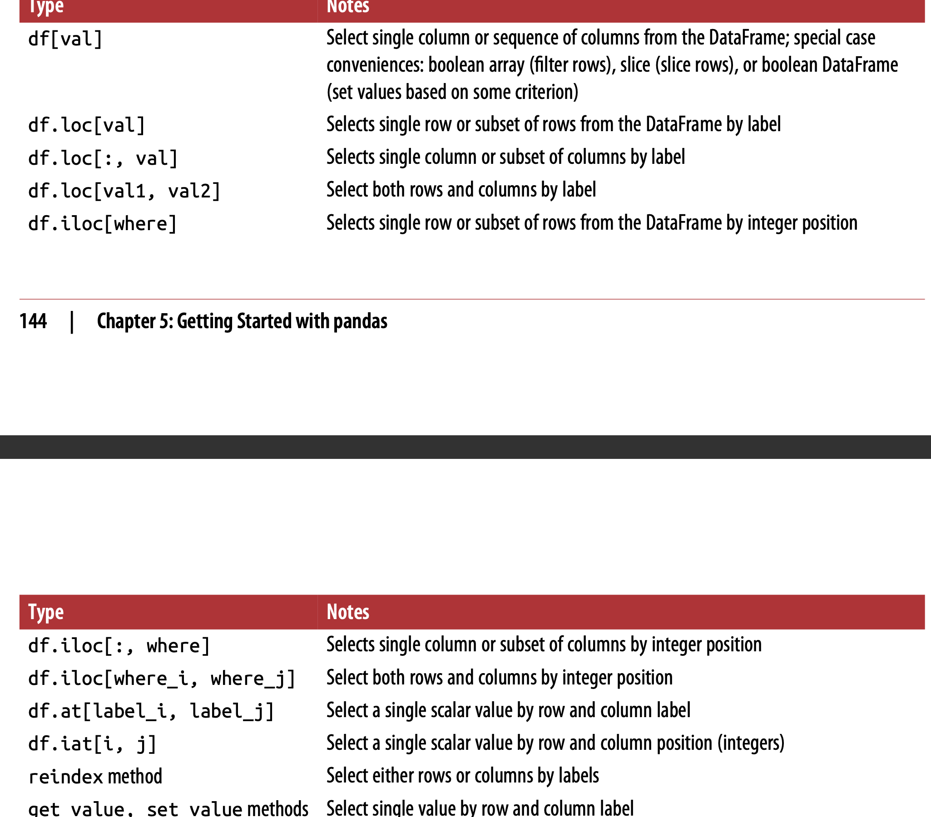
Arithmetic and Data Alignment
df1 + df2
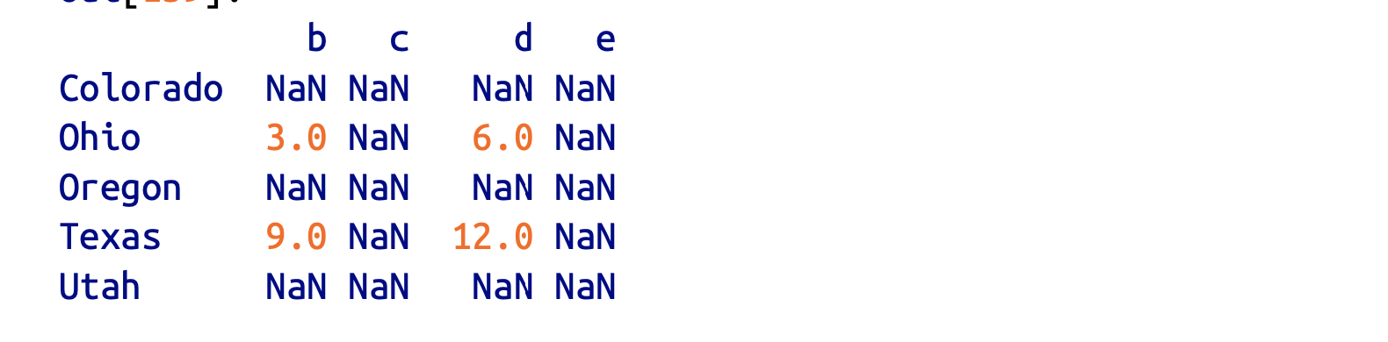

Arithmetic methods with fill values
df1.add(df2, fill_value=0)
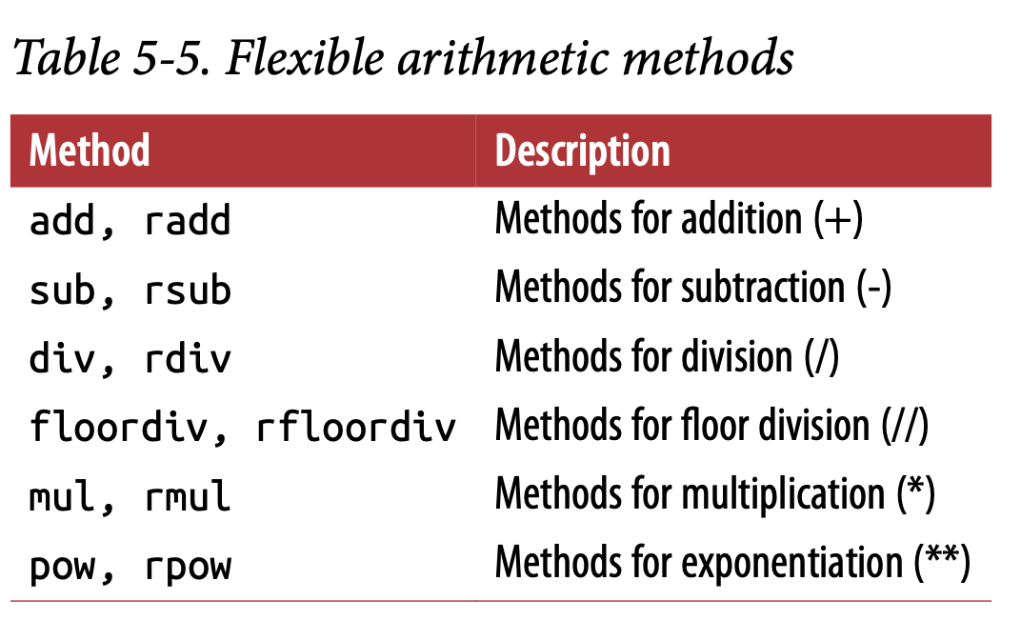

Operations between DataFrame and Series
arr - arr[0]
frame - series
frame + series2

frame.sub(series3, axis='index')

Function Application and Mapping
np.abs(frame)
f = lambda x: x.max() - x.min()
frame.apply(f) ==> function ‘f’ is invoked once per column
frame.apply(f, axis='columns') ==> function ‘f’ is invoked once per row

Idef f(x):
.....: return pd.Series([x.min(), x.max()], index=['min', 'max'])
frame.apply(f)

format = lambda x: '%.2f' % x
frame.applymap(format)

frame['e'].map(format)

Sorting and Ranking
obj.sort_index()
frame.sort_index()
frame.sort_index(axis=1)
frame.sort_index(axis=1, ascending=False)

obj.sort_values()
frame.sort_values(by='b')
frame.sort_values(by=['a', 'b']) ==> sort based on multiple columns.

obj = pd.Series([7, -5, 7, 4, 2, 0, 4])
obj.rank()
obj.rank(method='first')
obj.rank(ascending=False, method='max')

frame = pd.DataFrame({'b': [4.3, 7, -3, 2], 'a': [0, 1, 0, 1],
'c': [-2, 5, 8, -2.5]})

frame.rank(axis='columns')
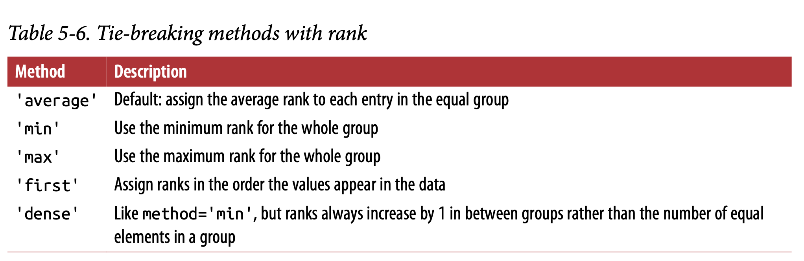
Axis Indexes with Duplicate Labels
obj.index.is_unique

5.3 Summarizing and Computing Descriptive Statistics
df.sum()
df.sum(axis = ‘columns’)
df.mean(axis='columns', skipna=False)
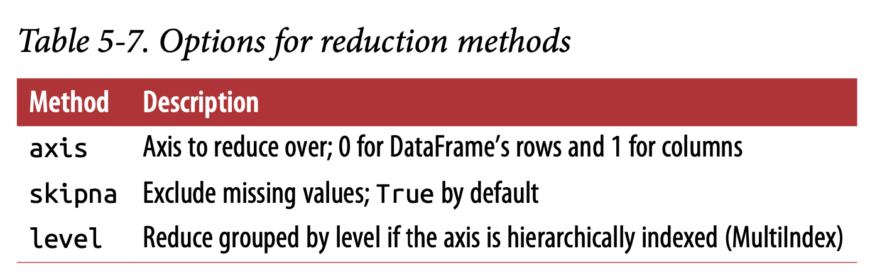

df.idxmax()
df.idxmin()
df.cumsum()
df.describe() ==> can be used on both numeric and non numeric data.

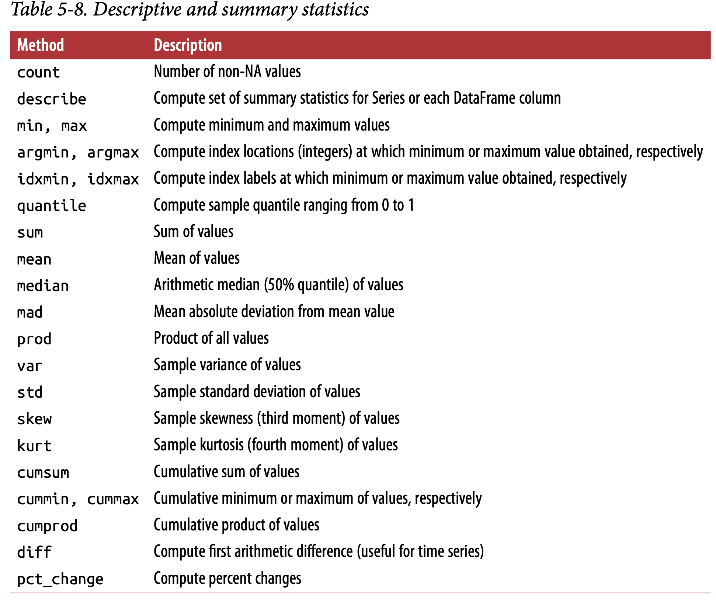

Correlation and Covariance
correlation and covariance, are computed from pairs of arguments.
returns = price.pct_change()
returns['MSFT'].corr(returns['IBM'])
returns['MSFT'].cov(returns['IBM'])

returns.MSFT.corr(returns.IBM) ==> another method.

returns.corr()
returns.cov()

returns.corrwith(returns.IBM)
returns.corrwith(volume)

Unique Values, Value Counts, and Membership
obj = pd.Series(['c', 'a', 'd', 'a', 'a', 'b', 'b', 'c', 'c'])
uniques = obj.unique()
uniques.sort()
obj.value_counts() ==> here it’s a series method.

value_counts is also available as a top-level pandas method that can be used with any array or sequence:
pd.value_counts(obj.values, sort=False) ==> here it’s pandas method.

mask = obj.isin(['b', 'c'])

to_match = pd.Series(['c', 'a', 'b', 'b', 'c', 'a'])
unique_vals = pd.Series(['c', 'b', 'a'])
pd.Index(unique_vals).get_indexer(to_match) ==> Index.get_indexer method
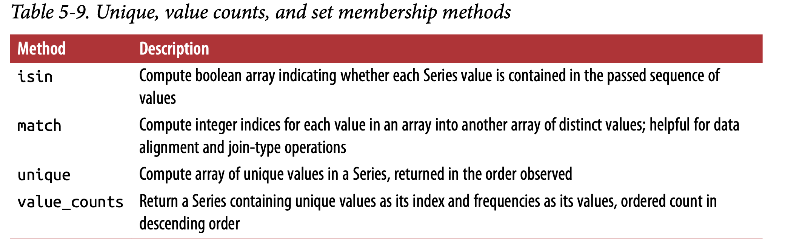
result = data.apply(pd.value_counts).fillna(0)

CHAPTER 6
Data Loading, Storage, and File Formats

6.1 Reading and Writing Data in Text Format

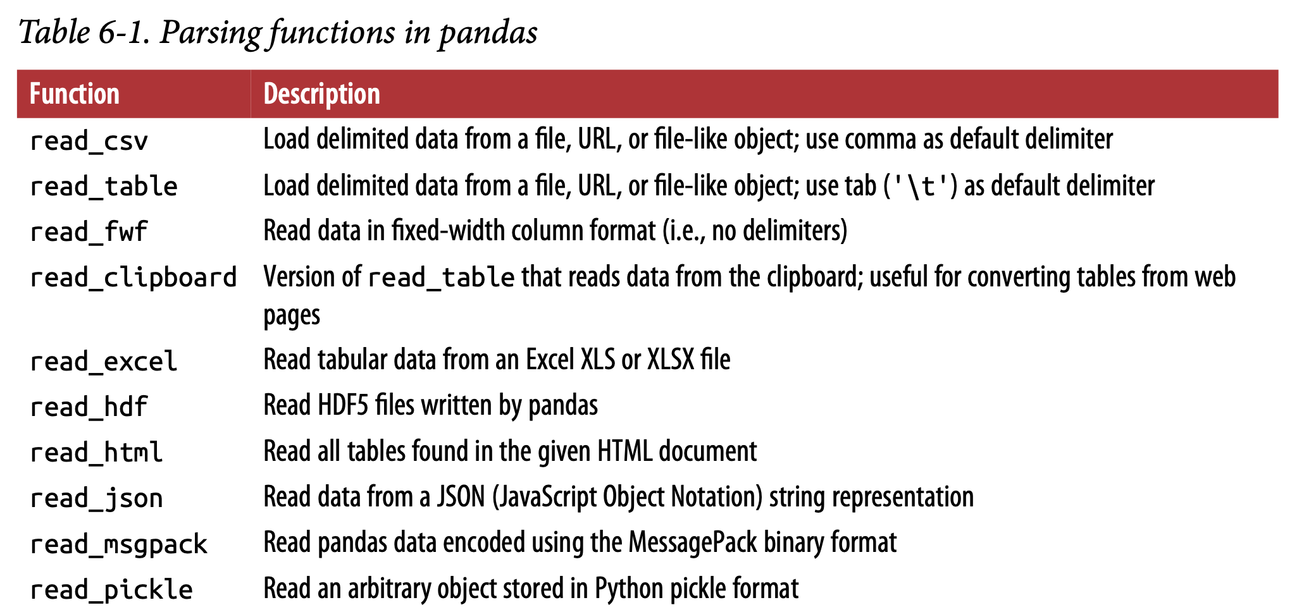
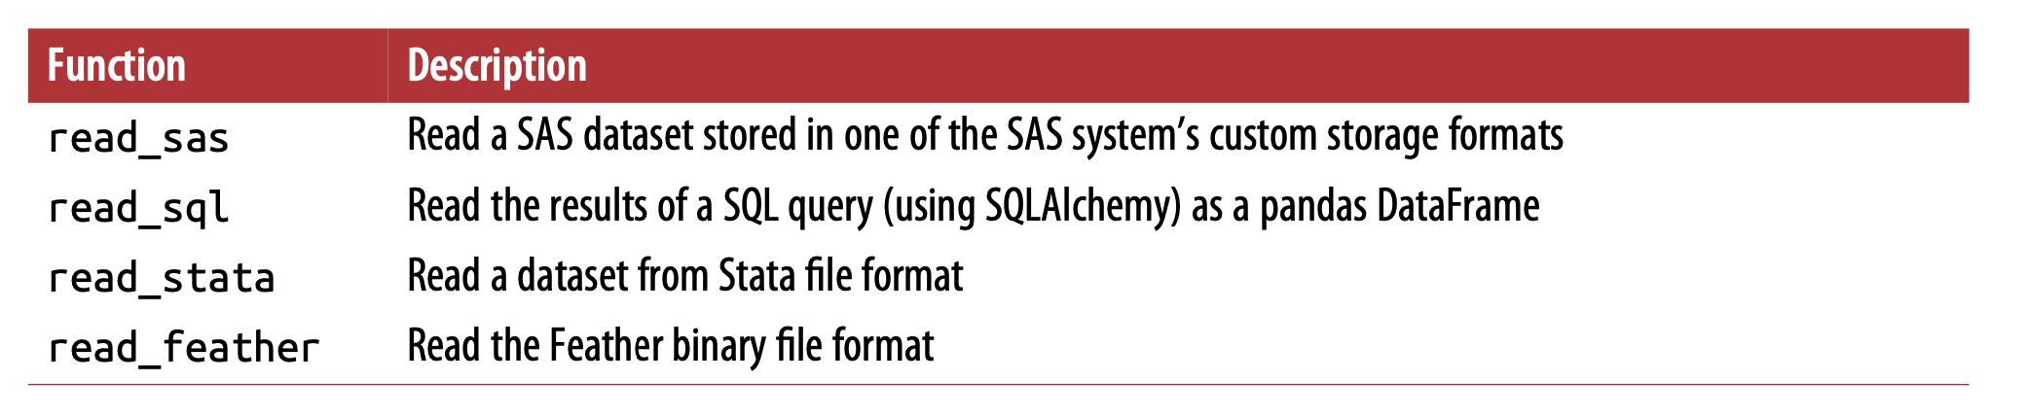
aa
df = pd.read_csv('examples/ex1.csv')
pd.read_table('examples/ex1.csv', sep=',')
pd.read_csv('examples/ex2.csv', header=None)
pd.read_csv('examples/ex2.csv', names=['a', 'b', 'c', 'd', 'message'])

names = ['a', 'b', 'c', 'd', 'message']
pd.read_csv('examples/ex2.csv', names=names, index_col='message')

parsed = pd.read_csv('examples/csv_mindex.csv', index_col=['key1', 'key2'])

result = pd.read_table('examples/ex3.txt', sep='\s+')

pd.read_csv('examples/ex4.csv', skiprows=[0, 2, 3])

result = pd.read_csv('examples/ex5.csv', na_values=['NULL'])

Different NA sentinels can be specified for each column in a dict:
sentinels = {'message': ['foo', 'NA'], 'something': ['two']}
pd.read_csv('examples/ex5.csv', na_values=sentinels)

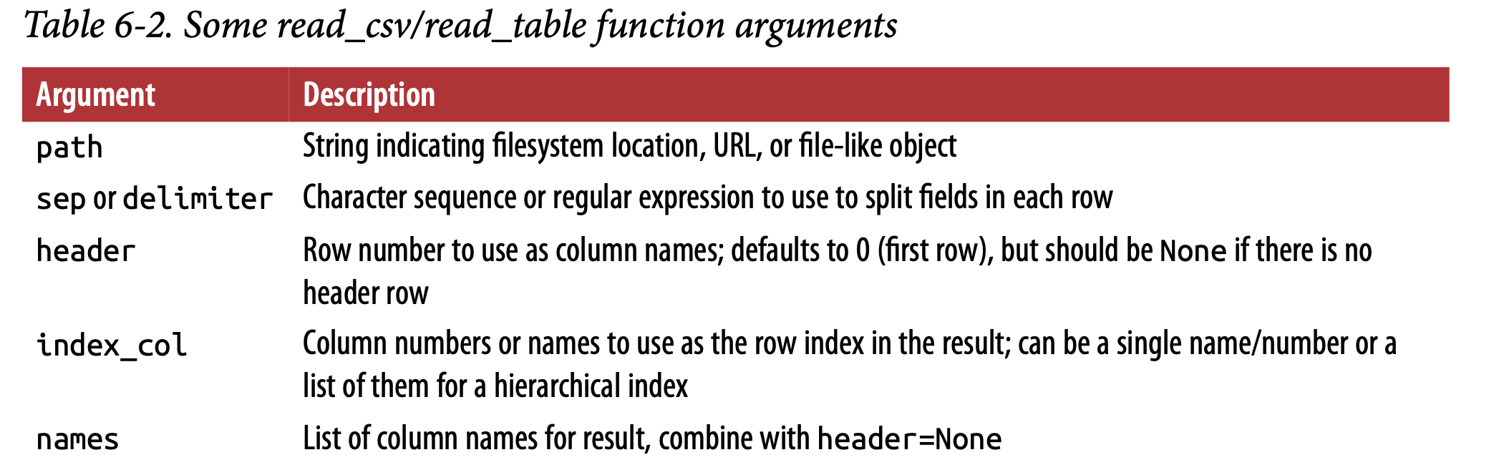
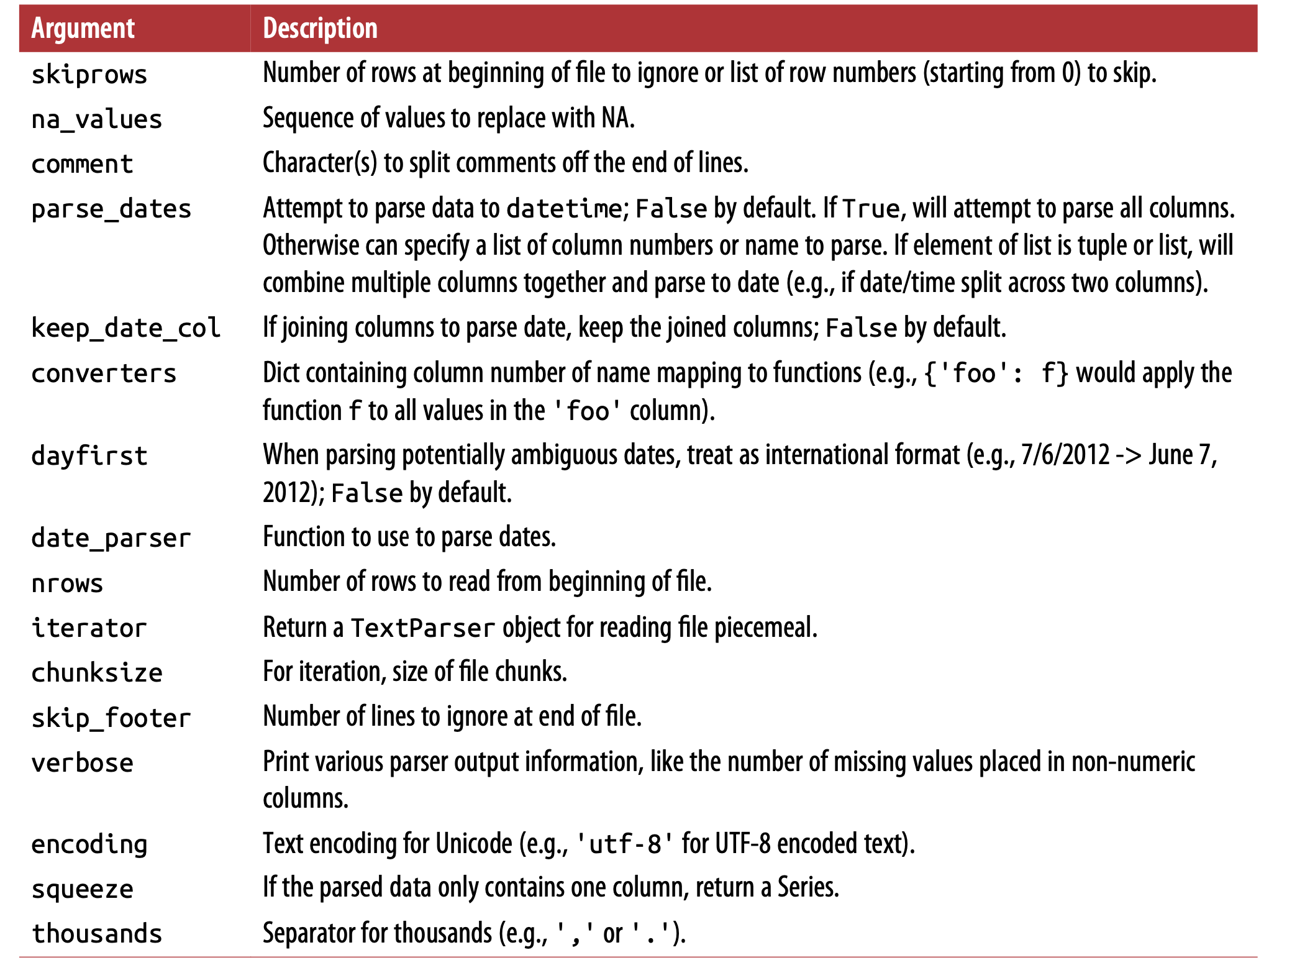
aa
Reading Text Files in Pieces
pd.options.display.max_rows = 10

pd.read_csv('examples/ex6.csv', nrows=5)
chunker = pd.read_csv('examples/ex6.csv', chunksize=1000)

Writing Data to Text Format
data.to_csv('examples/out.csv')

import sys
data.to_csv(sys.stdout, sep='|')

data.to_csv(sys.stdout, na_rep='NULL')
data.to_csv(sys.stdout, index=False, header=False)

write only a subset of the columns
data.to_csv(sys.stdout, index=False, columns=['a', 'b', 'c'])

Series also has a to_csv method:
dates = pd.date_range('1/1/2000', periods=7)
ts = pd.Series(np.arange(7), index=dates)
ts.to_csv('examples/tseries.csv')

Working with Delimited Formats
import csv
f = open('examples/ex7.csv')
reader = csv.reader(f)

with open('examples/ex7.csv') as f:
lines = list(csv.reader(f))
header, values = lines[0], lines[1:]

reader = csv.reader(f, dialect=my_dialect)
reader = csv.reader(f, delimiter='|')

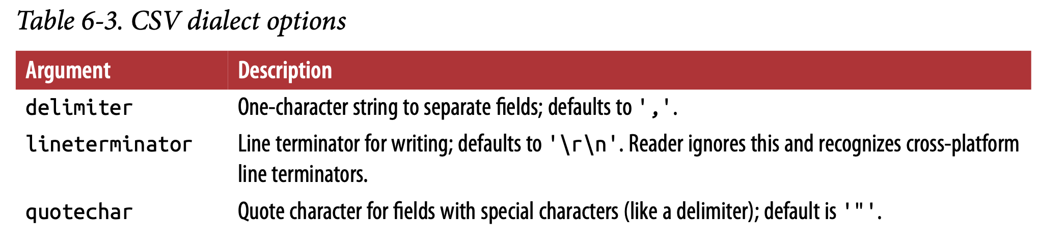
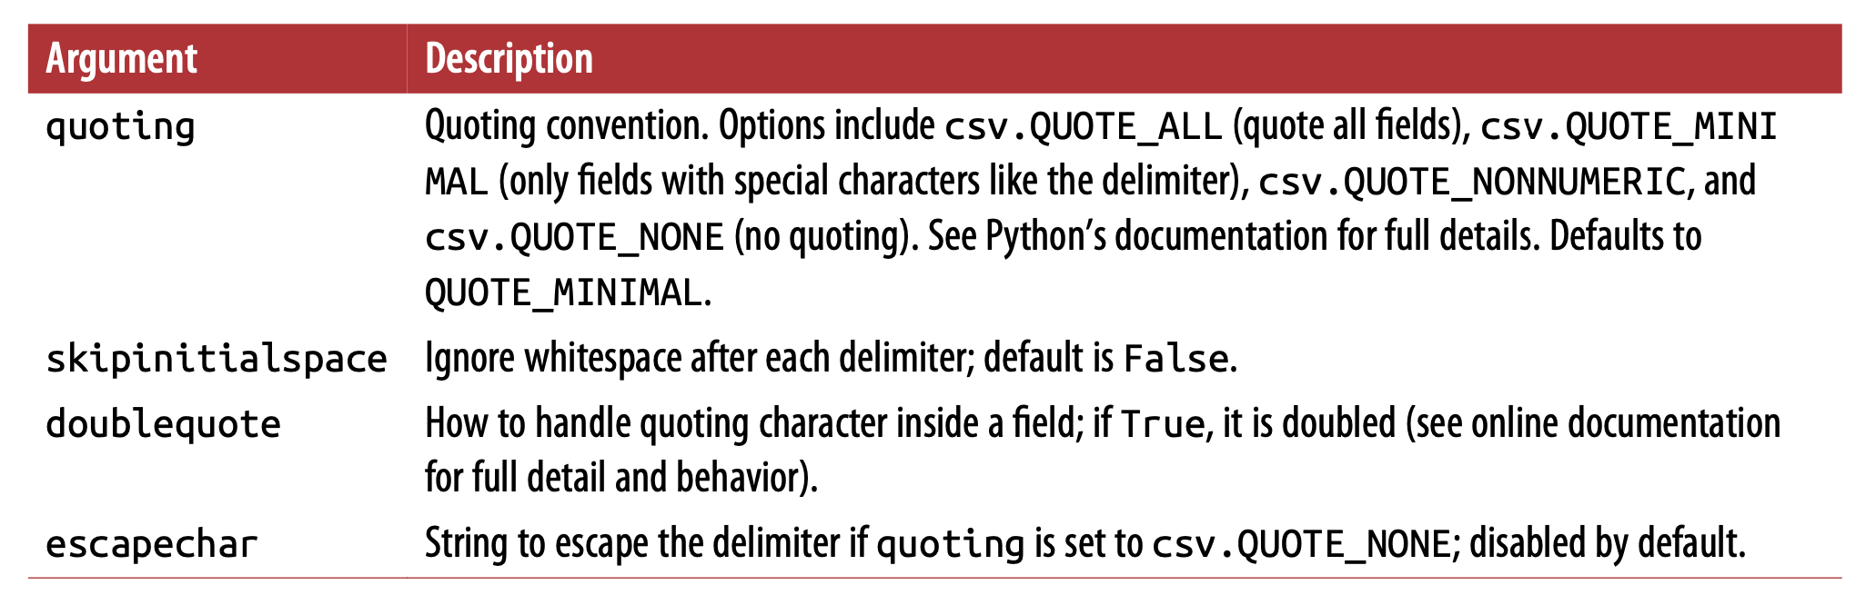
aa
JSON Data (JavaScript Object Notation)
import json
result = json.loads(obj)

json.dumps, on the other hand, converts a Python object back to JSON:
asjson = json.dumps(result)

siblings = pd.DataFrame(result['siblings'], columns=['name', 'age'])

data = pd.read_json('examples/example.json')

print(data.to_json())
print(data.to_json(orient='records'))

XML and HTML: Web Scraping
tables = pd.read_html('examples/fdic_failed_bank_list.html')

Parsing XML with lxml.objectify
XML (eXtensible Markup Language)

from lxml import objectify
path = 'examples/mta_perf/Performance_MNR.xml'
parsed = objectify.parse(open(path))
root = parsed.getroot()

6.2 Binary Data Formats
frame.to_pickle('examples/frame_pickle')
pd.read_pickle('examples/frame_pickle')
pickle is only recommended as a short-term storage format.

Using HDF5 Format
Need to read in book directly.
Note: Python for Parquet and other such storage formats is still develop‐ ing, so I do not write about them in this book.

Reading Microsoft Excel Files
xlsx = pd.ExcelFile('examples/ex1.xlsx')
pd.read_excel(xlsx, 'Sheet1')

writer = pd.ExcelWriter('examples/ex2.xlsx')
frame.to_excel(writer, 'Sheet1')

writer.save()

frame.to_excel('examples/ex2.xlsx')

6.3 Interacting with Web APIs
import requests
url = 'https://api.github.com/repos/pandas-dev/pandas/issues'
resp = requests.get(url)
data = resp.json()

6.4 Interacting with Databases
cursor = con.execute('select * from test')
rows = cursor.fetchall()
cursor.description

pd.read_sql('select * from test', db)

CHAPTER 7
Data Cleaning and Preparation
string_data.isnull()

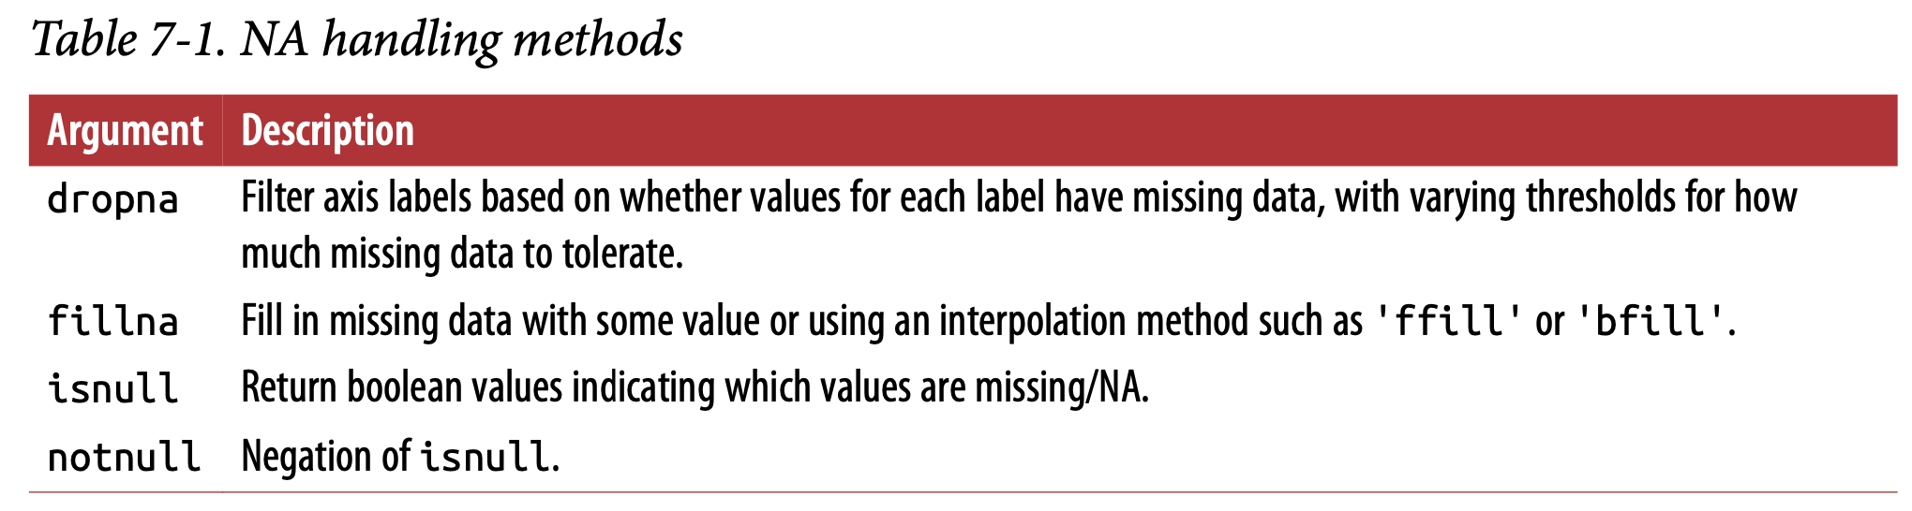
aa
Filtering Out Missing Data
cleaned = data.dropna() ==> this is equivalent to data[data.notnull()]
On DataFrame dropna() function by default drops any row containing a missing value.
Passing how='all' will only drop rows that are all NA
data.dropna(how='all')
data.dropna(axis=1, how='all') ==> to drop columns having full NA
df.dropna(thresh=2)
Note: If we want to populate NULL in to a column then need to follow below steps:
from numpy import nan as NA
data[4] = NA or data[4] = None or data[4] = np.nan
we cannot do as data[4] = NaN or data[4] = ‘NaN’ or data[4] = Null etc...

Filling In Missing Data
df.fillna(0)
df.fillna({1: 0.5, 2: 0})
df = df.fillna(0, inplace=True)
df.fillna(method='ffill')
df.fillna(method='ffill', limit=2)
data.fillna(data.mean())
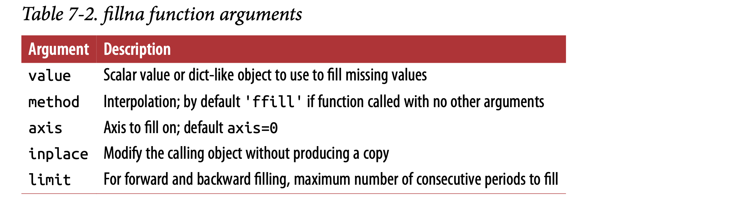
7.2 Data Transformation
Removing Duplicates
data.duplicated()
data.drop_duplicates()
data.drop_duplicates(['k1'])
data.drop_duplicates(['k1', 'k2'], keep='last')

Transforming Data Using a Function or Mapping
data['animal'] = lowercased.map(meat_to_animal)
or
data['food'].map(lambda x: meat_to_animal[x.lower()])
Replacing Values
data.replace(-999, np.nan)
data.replace([-999, -1000], np.nan)
data.replace([-999, -1000], [np.nan,0])
data.replace({-999: np.nan,-1000:0})

Renaming Axis Indexes
transform = lambda x: x[:4].upper() ==> a function is defined.
data.index.map(transform)
data.index = data.index.map(transform)

data.rename(index=str.title, columns=str.upper)

data.rename(index={'OHIO': 'INDIANA'}, columns={'three': 'peekaboo'})

data.rename(index={'OHIO': 'INDIANA'}, inplace=True)

Discretization and Binning
ages = [20, 22, 25, 27, 21, 23, 37, 31, 61, 45, 41, 32]
bins = [18, 25, 35, 60, 100]
cats = pd.cut(ages, bins)
cats.categories
cats.codes
pd.value_counts(cats)

pd.cut(ages, [18, 26, 36, 61, 100], right=False)

group_names = ['Youth', 'YoungAdult', 'MiddleAged', 'Senior']
pd.cut(ages, bins, labels=group_names)

pd.cut(data, 4, precision=2)

cats = pd.qcut(data, 4)

pd.qcut(data, [0, 0.1, 0.5, 0.9, 1.]) ==> you can pass your own quantiles

Detecting and Filtering Outliers
data = pd.DataFrame(np.random.randn(1000, 4))
col = data[2]

col[np.abs(col) > 3]

data[(np.abs(data) > 3).any(1)]
data[np.abs(data) > 3] = np.sign(data) * 3

np.sign(data).head() ==> produces 1 and –1 values based on whether the values in data are positive or negative.

Permutation and Random Sampling
df = pd.DataFrame(np.arange(5 * 4).reshape((5, 4)))
sampler = np.random.permutation(5)
df.take(sampler)
df.sample(n=3)

choices = pd.Series([5, 7, -1, 6, 4])

draws = choices.sample(n=10, replace=True)

Computing Indicator/Dummy Variables
Not able to understand, may need to read later.

7.3 String Manipulation
String Object Methods
val = 'a,b, guido'
val.split(',')

pieces = [x.strip() for x in val.split(',')]
first, second, third = pieces

first + '::' + second + '::' + third
or
'::'.join(pieces)

'guido' in val
val.index(',')
val.find(':')
val.count(',')
val.replace(',', '::')
val.replace(',', '')
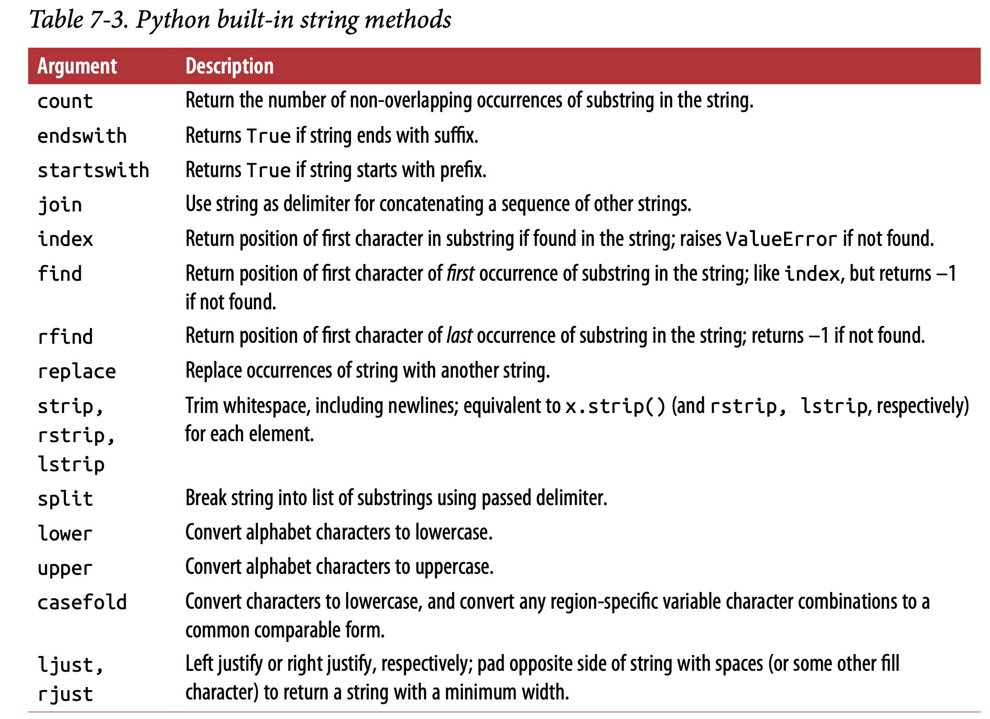
Regular Expressions
import re
text = "foo bar\t baz \tqux"
re.split('\s+', text)

regex = re.compile('\s+')
regex.findall(text)

text = """Dave dave@google.com Steve steve@gmail.com
Rob rob@gmail.com
Ryan ryan@yahoo.com
"""
pattern = r'[A-Z0-9._%+-]+@[A-Z0-9.-]+\.[A-Z]{2,4}'
regex = re.compile(pattern, flags=re.IGNORECASE)
regex.findall(text)

m = regex.search(text)
text[m.start():m.end()]
print(regex.match(text))
print(regex.sub('REDACTED', text))

pattern = r'([A-Z0-9._%+-]+)@([A-Z0-9.-]+)\.([A-Z]{2,4})'
regex = re.compile(pattern, flags=re.IGNORECASE)
m = regex.match('wesm@bright.net')
m.groups()

regex.findall(text)

print(regex.sub(r'Username: \1, Domain: \2, Suffix: \3', text))

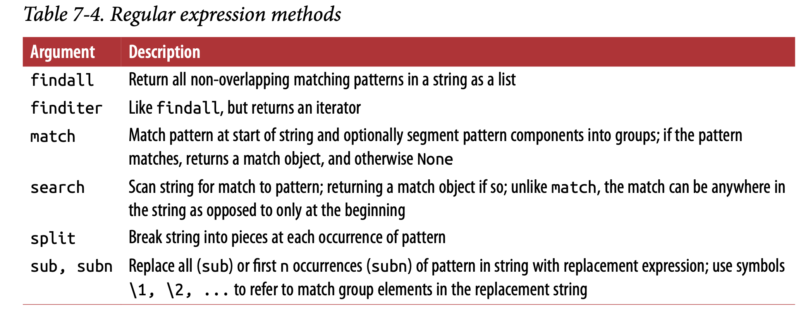
Vectorized String Functions in pandas

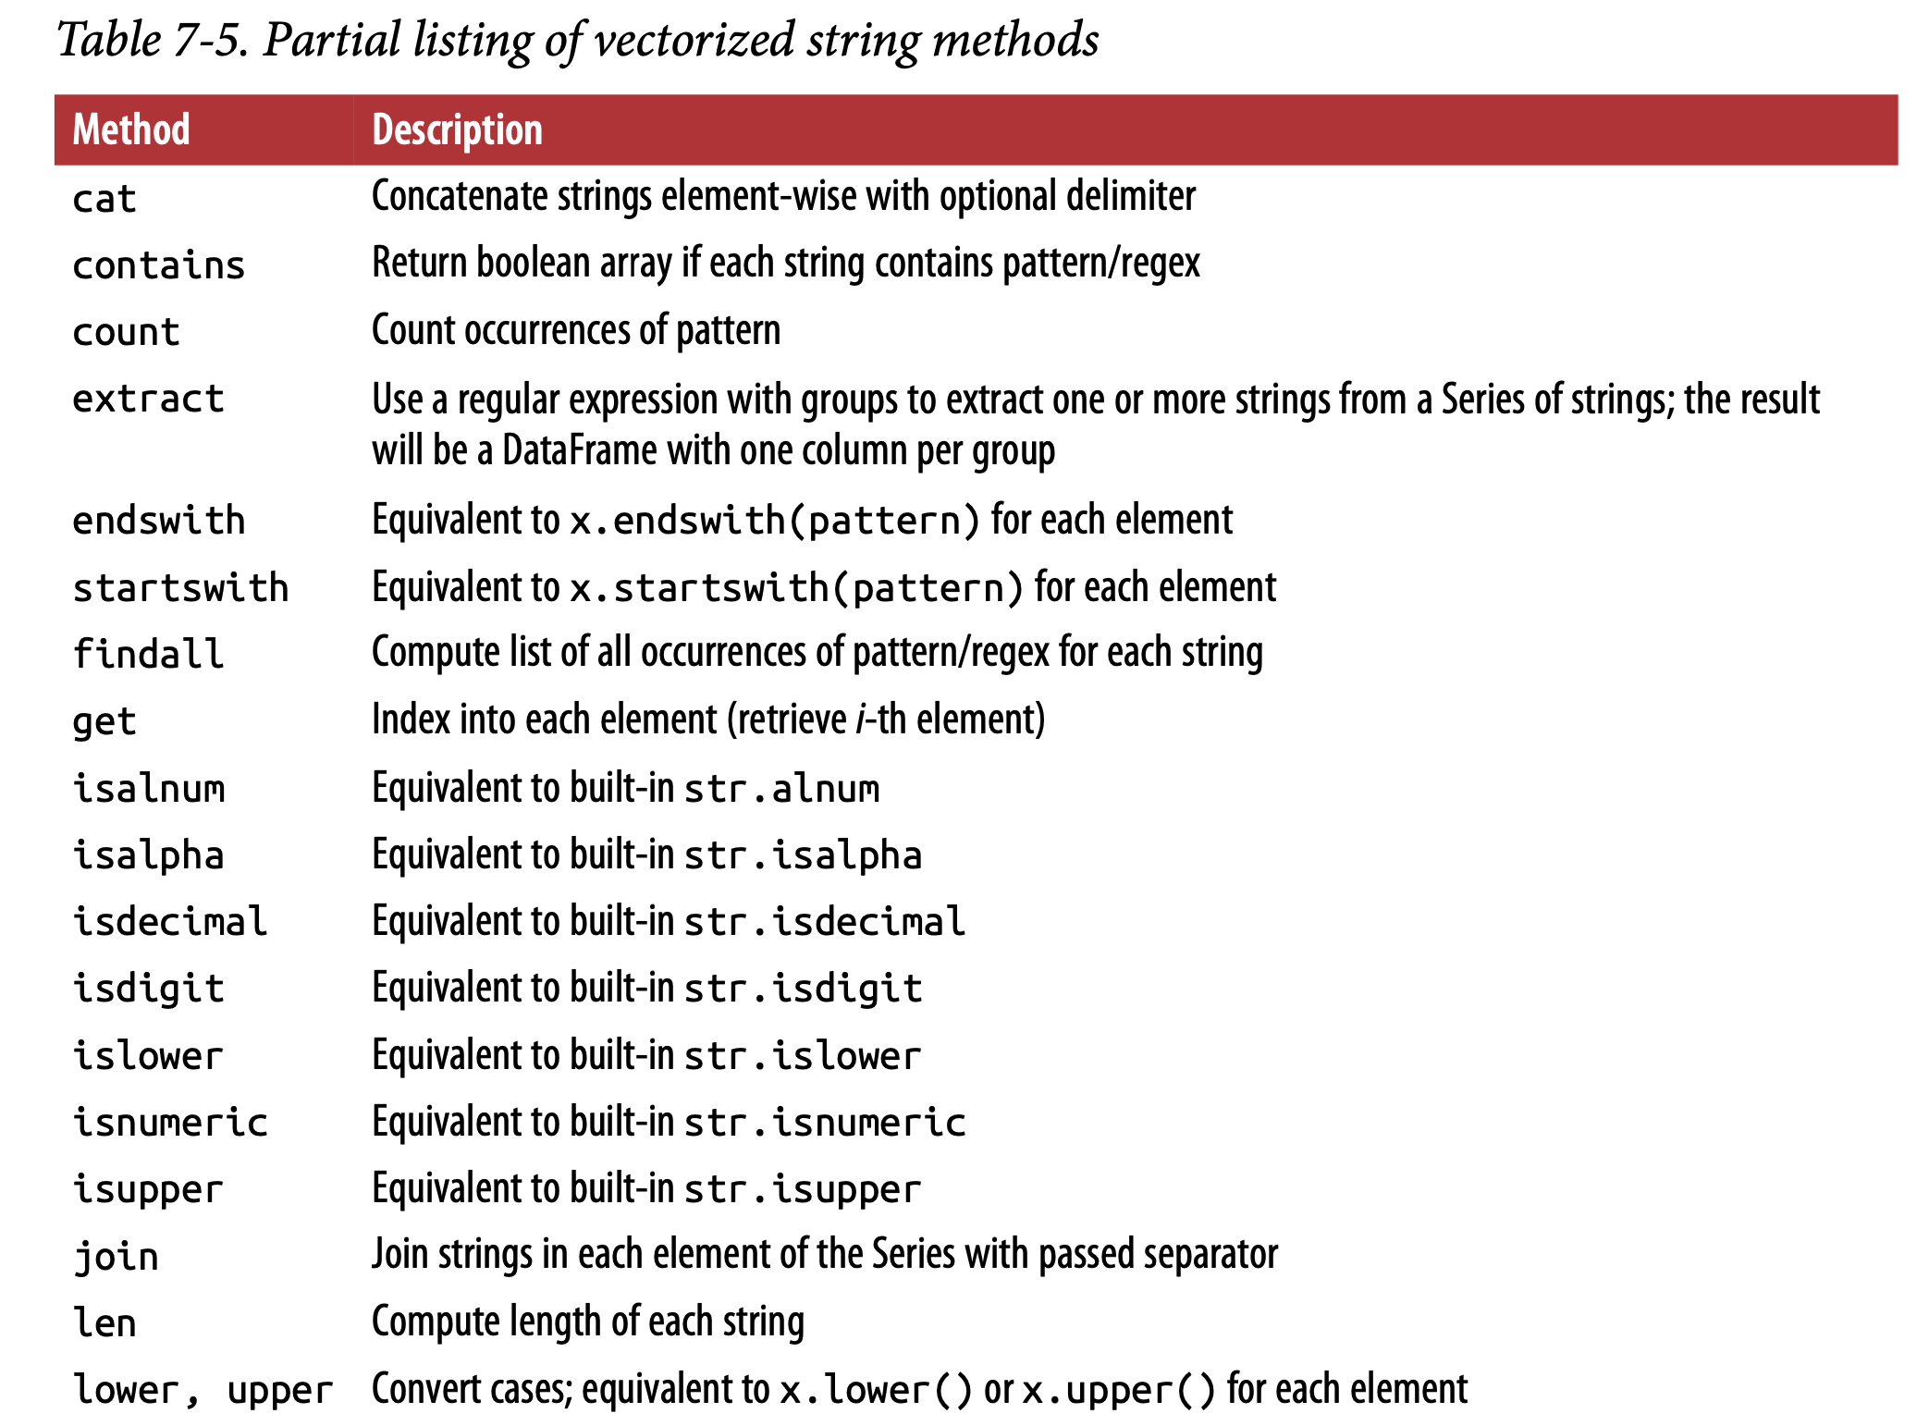
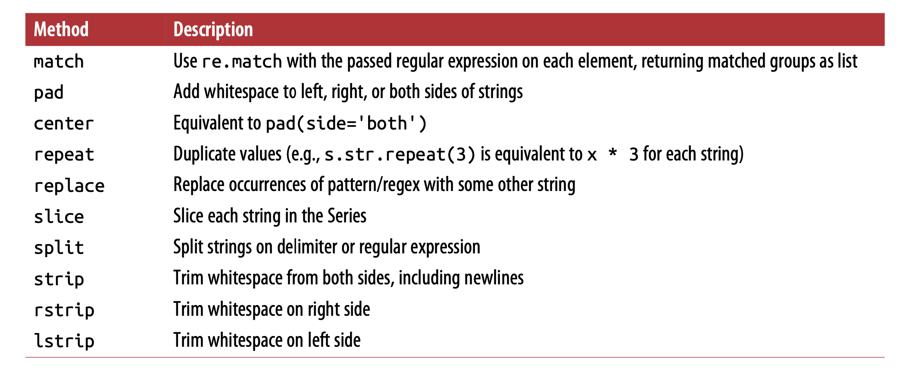

CHAPTER 8 :
Data Wrangling: Join, Combine, and Reshape
8.1 Hierarchical Indexing

data.index

data.unstack()
data.unstack().stack()

Reordering and Sorting Levels

frame.swaplevel('key1', 'key2')

frame.sort_index(level=1) Out[25]:

frame.swaplevel(0, 1).sort_index(level=0)

Summary Statistics by Level
frame.sum(level='key2')

frame.sum(level='color', axis=1)

Indexing with a DataFrame’s columns
frame2 = frame.set_index(['c', 'd'])
frame.set_index(['c', 'd'], drop=False)

frame2.reset_index()

8.2 Combining and Merging Datasets
Database-Style DataFrame Joins
df1 = pd.DataFrame({'key': ['b', 'b', 'a', 'c', 'a', 'a', 'b'], 'data1': range(7)})
df2 = pd.DataFrame({'key': ['a', 'b', 'd'], 'data2': range(3)})

pd.merge(df1, df2)
pd.merge(df1, df2, on='key')
pd.merge(df3, df4, left_on='lkey', right_on='rkey')

By default merge does an 'inner' join;

pd.merge(df1, df2, how='outer')
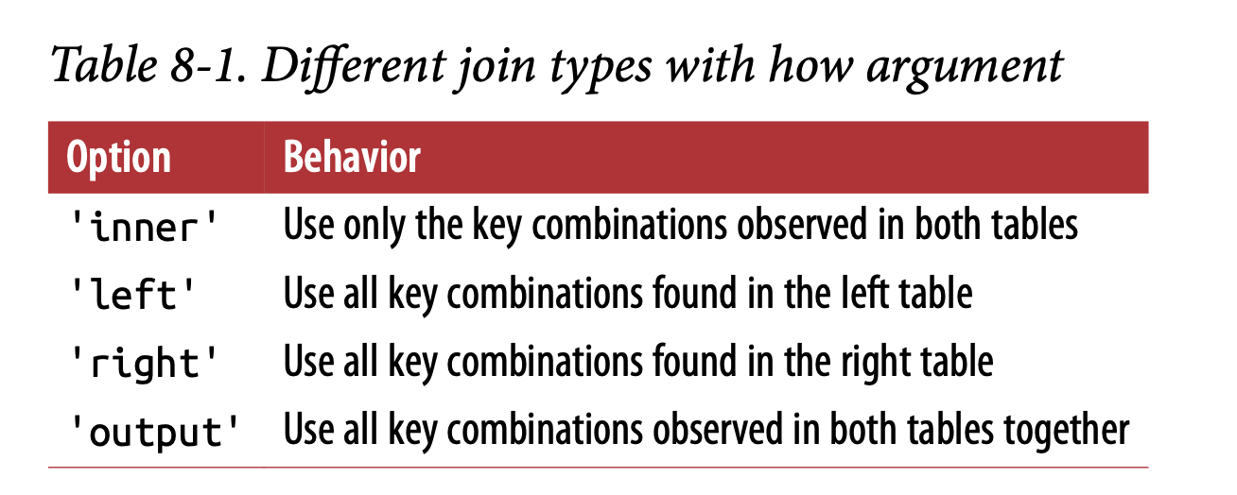

pd.merge(df1, df2, on='key', how='left')
pd.merge(df1, df2, how='inner')

To merge with multiple keys, pass a list of column names:
pd.merge(left, right, on=['key1', 'key2'], how='outer')

Merge has a suffixes option for specifying strings to append to overlapping names in the left and right DataFrame objects:
pd.merge(left, right, on='key1', suffixes=('_left', '_right'))
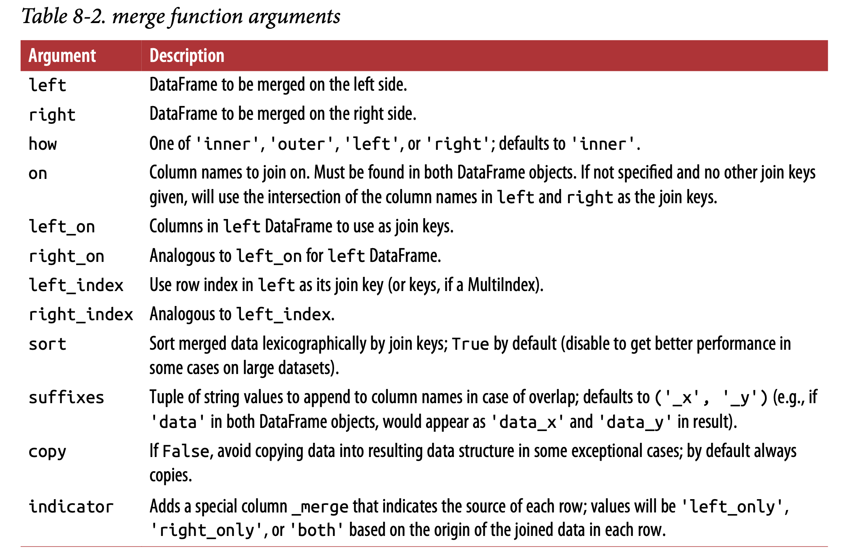
Merging on Index

In some cases, the merge key(s) in a DataFrame will be found in its index. In this case, you can pass left_index=True or right_index=True (or both) to indicate that the index should be used as the merge key:
pd.merge(left1, right1, left_on='key', right_index=True)
pd.merge(left1, right1, left_on='key', right_index=True, how='outer')

pd.merge(lefth, righth, left_on=['key1', 'key2'], right_index=True)
pd.merge(lefth, righth, left_on=['key1', 'key2'], right_index=True, how='outer')

pd.merge(left2, right2, how='outer', left_index=True, right_index=True)

left2.join(right2, how='outer')
left1.join(right1, on='key')

Lastly, for simple index-on-index merges, you can pass a list of DataFrames to join as an alternative
left2.join([right2, another])
left2.join([right2, another], how='outer')

Concatenating Along an Axis
arr = np.arange(12).reshape((3, 4))
np.concatenate([arr, arr], axis=1)
By default concat works along axis=0.

pd.concat([s1, s4], axis=1, join='inner')

pd.concat([s1, s4], axis=1, join_axes=[['a', 'c', 'b', 'e']])

result = pd.concat([s1, s1, s3], keys=['one', 'two', 'three'])
result.unstack()

pd.concat([s1, s2, s3], axis=1, keys=['one', 'two', 'three'])

The same logic extends to DataFrame objects:
pd.concat([df1, df2], axis=1, keys=['level1', 'level2'])

pd.concat({'level1': df1, 'level2': df2}, axis=1)

pd.concat([df1, df2], axis=1, keys=['level1', 'level2'],names=['upper', 'lower'])

pd.concat([df1, df2], ignore_index=True)
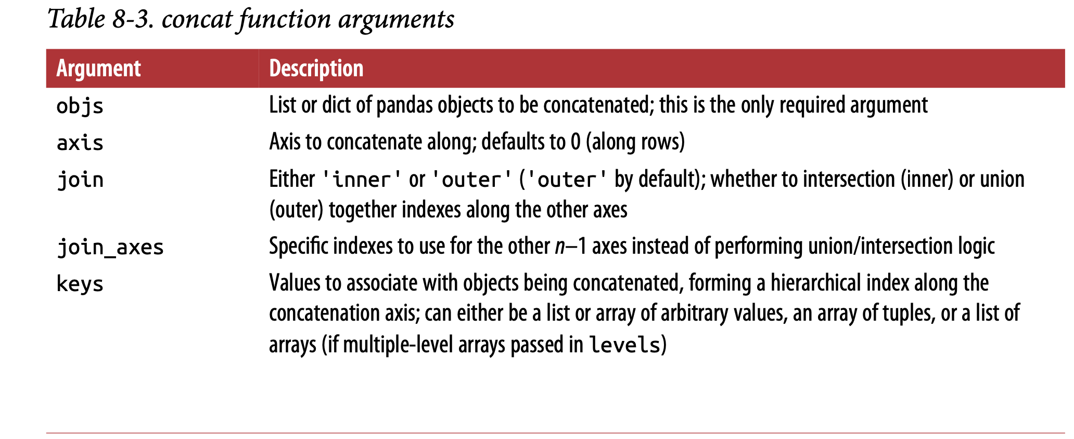
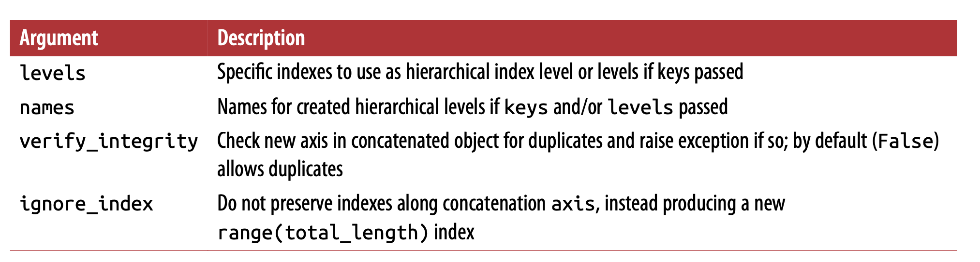

Combining Data with Overlap
np.where(pd.isnull(a), b, a) ==> if ‘a’ is NULL then ‘b’ value is fetched.

b[:-2].combine_first(a[2:])

df1.combine_first(df2)

8.3 Reshaping and Pivoting
Reshaping with Hierarchical Indexing
stack
This “rotates” or pivots from the columns in the data to the rows
unstack
This pivots from the rows into the columns

result = data.stack()
result.unstack()
result.unstack(0)
result.unstack('state')
data2.unstack().stack()
data2.unstack().stack(dropna=False)
df.unstack('state').stack('side')

Pivoting “Long” to “Wide” Format

periods = pd.PeriodIndex(year=data.year, quarter=data.quarter, name='date')
PeriodIndex combines the year and quarter columns to create a kind of time interval type.

pivoted = ldata.pivot('date', 'item', 'value')
pivoted = ldata.pivot('date', 'item')
pivoted['value'][:5]

Pivoting “Wide” to “Long” Format
melted = pd.melt(df, ['key'])

reshaped = melted.pivot('key', 'variable', 'value')
reshaped.reset_index()
pd.melt(df, id_vars=['key'], value_vars=['A', 'B'])
pd.melt(df, value_vars=['A', 'B', 'C'])
pd.melt(df, value_vars=['key', 'A', 'B'])

CHAPTER 9
Plotting and Visualization
import matplotlib.pyplot as plt
data = np.arange(10)
plt.plot(data)

Figures and Subplots
fig = plt.figure()
ax1 = fig.add_subplot(2, 2, 1)
ax2 = fig.add_subplot(2, 2, 2)
ax3 = fig.add_subplot(2, 2, 3)

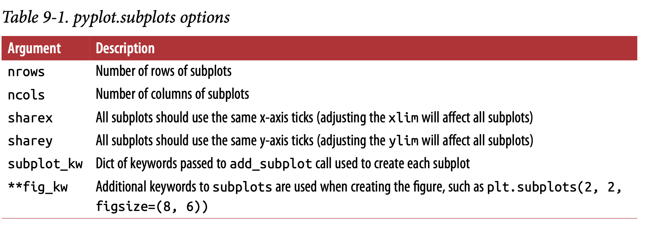
Line Plots
s = pd.Series(np.random.randn(10).cumsum(), index=np.arange(0, 100, 10))
s.plot()

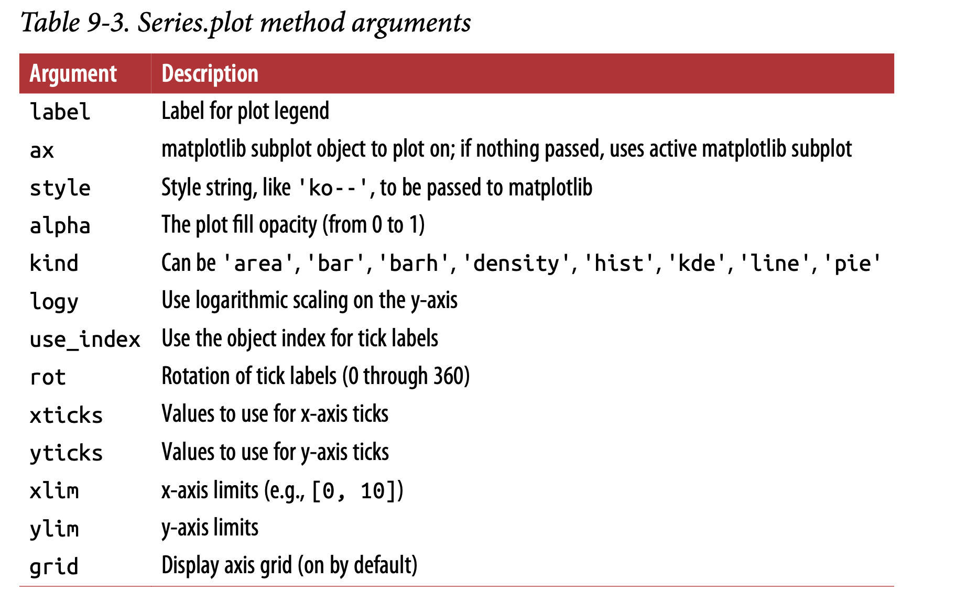

df = pd.DataFrame(np.random.randn(10, 4).cumsum(0),
- ....: columns=['A', 'B', 'C', 'D'],
- ....: index=np.arange(0, 100, 10))
df.plot()

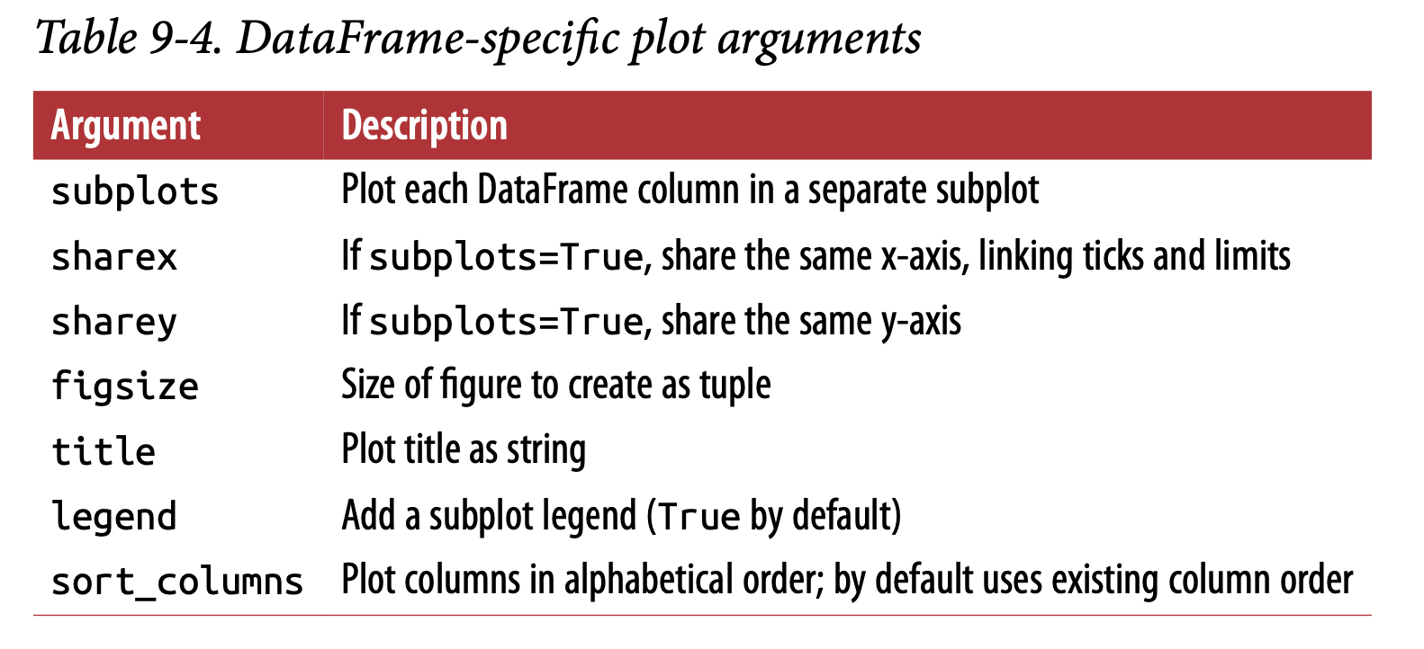
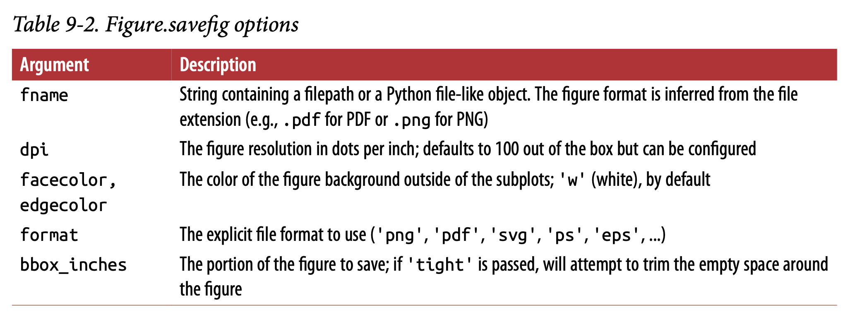
For remaining its easy to see the video and learn, in youture have added 2 videos to DataScience library, one from Edureka and other from SentDex.

Visulization based on Seaborn is also from youtube, have added 2 videos to DataScience library, one from Edureka and other from Abhishek Agarwal.
For practise:
https://www.tutorialspoint.com/matplotlib/index.htm
Below person tutorials are awesome, he has explained very well. Need to see all videos.
https://www.youtube.com/watch?v=b3lK639ymu4&list=PLNmACol6lYY5aGQtxghQTq0bHXYoIMORy

CHAPTER 10
Data Aggregation and Group Operations
df
= pd.DataFrame({'key1' : ['a', 'a', 'b', 'b', 'a'],
'key2' : ['one', 'two', 'one', 'two', 'one'],
'data1' : np.random.randn(5), 'data2' : np.random.randn(5)})

grouped = df['data1'].groupby(df['key1'])
grouped.mean()

means = df['data1'].groupby([df['key1'], df['key2']]).mean()
means.unstack()

df.groupby('key1').mean()
df.groupby(['key1', 'key2']).mean()

df.groupby(['key1', 'key2']).size()

Iterating Over Groups
for name, group in df.groupby('key1'):
print(name)
print(group)

for (k1, k2), group in df.groupby(['key1', 'key2']):
print((k1, k2))
print(group)

grouped = df.groupby(df.dtypes, axis=1)
for dtype, group in grouped:
print(dtype)
print(group)

Selecting a Column or Subset of Columns
To aggregate only a few columns
df.groupby(['key1', 'key2'])[['data2']].mean()

Grouping with Dicts and Series
Grouping with Functions
people.groupby(len).sum()

key_list = ['one', 'one', 'one', 'two', 'two']
people.groupby([len, key_list]).min()

Grouping by Index Levels
hier_df.groupby(level='cty', axis=1).count()

10.2 Data Aggregation
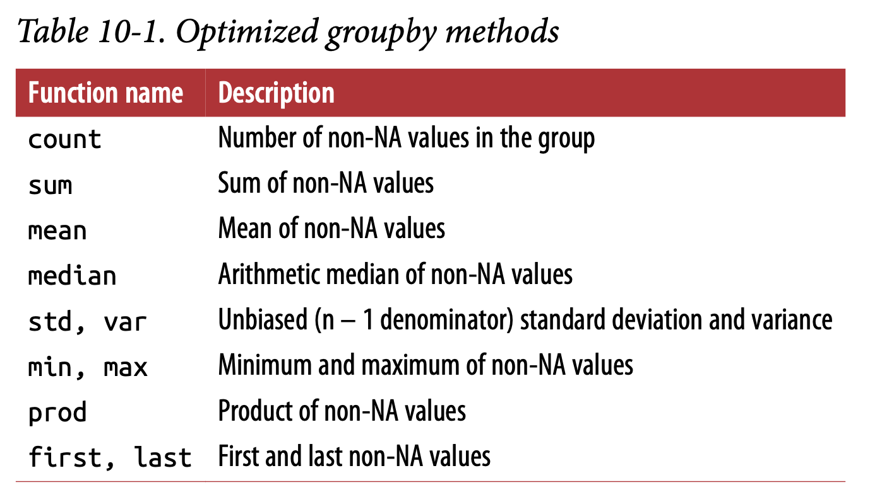

grouped = df.groupby('key1')
grouped['data1'].quantile(0.9)

grouped.describe()

Column-Wise and Multiple Function Application
grouped = tips.groupby(['day', 'smoker'])
grouped_pct = grouped['tip_pct']
grouped_pct.agg('mean')
grouped_pct.agg(['mean', 'std', peak_to_peak])
grouped_pct.agg([('foo', 'mean'), ('bar', np.std)])

functions = ['count', 'mean', 'max']
result = grouped['tip_pct', 'total_bill'].agg(functions)

ftuples = [('Durchschnitt', 'mean'), ('Abweichung', np.var)]
grouped['tip_pct', 'total_bill'].agg(ftuples)

grouped.agg({'tip' : np.max, 'size' : 'sum'})
grouped.agg({'tip_pct' : ['min', 'max', 'mean', 'std'], 'size' : 'sum'})

Returning Aggregated Data Without Row Indexes
tips.groupby(['day', 'smoker'], as_index=False).mean()

10.3 Apply: General split-apply-combine
def top(df, n=5, column='tip_pct'):
return df.sort_values(by=column)[-n:]

tips.groupby('smoker').apply(top)
tips.groupby(['smoker', 'day']).apply(top, n=1, column='total_bill')

result = tips.groupby('smoker')['tip_pct'].describe()

Suppressing the Group Keys
tips.groupby('smoker', group_keys=False).apply(top)

Quantile and Bucket Analysis :
frame = pd.DataFrame({'data1': np.random.randn(1000), 'data2': np.random.randn(1000)})
quartiles = pd.cut(frame.data1, 4)

def get_stats(group):
return {'min': group.min(), 'max': group.max(),
'count': group.count(), 'mean': group.mean()}

grouped = frame.data2.groupby(quartiles)
grouped.apply(get_stats).unstack()

# Return quantile numbers

grouping = pd.qcut(frame.data1, 10, labels=False)
grouped = frame.data2.groupby(grouping)
grouped.apply(get_stats).unstack()

Example: Filling Missing Values with Group-Specific Values
s.fillna(s.mean())
Remaining need to read from book.
Example: Random Sampling and Permutation
Need to read from book.
Example: Group Weighted Average and Correlation
Need to read from book.
Example: Group-Wise Linear Regression

10.4 Pivot Tables and Cross-Tabulation
tips.pivot_table(index=['day', 'smoker'])
tips.pivot_table(['tip_pct', 'size'], index=['time', 'day'], columns='smoker')

tips.pivot_table(['tip_pct', 'size'], index=['time', 'day'], columns='smoker', margins=True)
tips.pivot_table('tip_pct', index=['time', 'smoker'], columns='day',aggfunc=len, margins=True)

tips.pivot_table('tip_pct', index=['time', 'size', 'smoker'],columns='day', aggfunc='mean', fill_value=0)

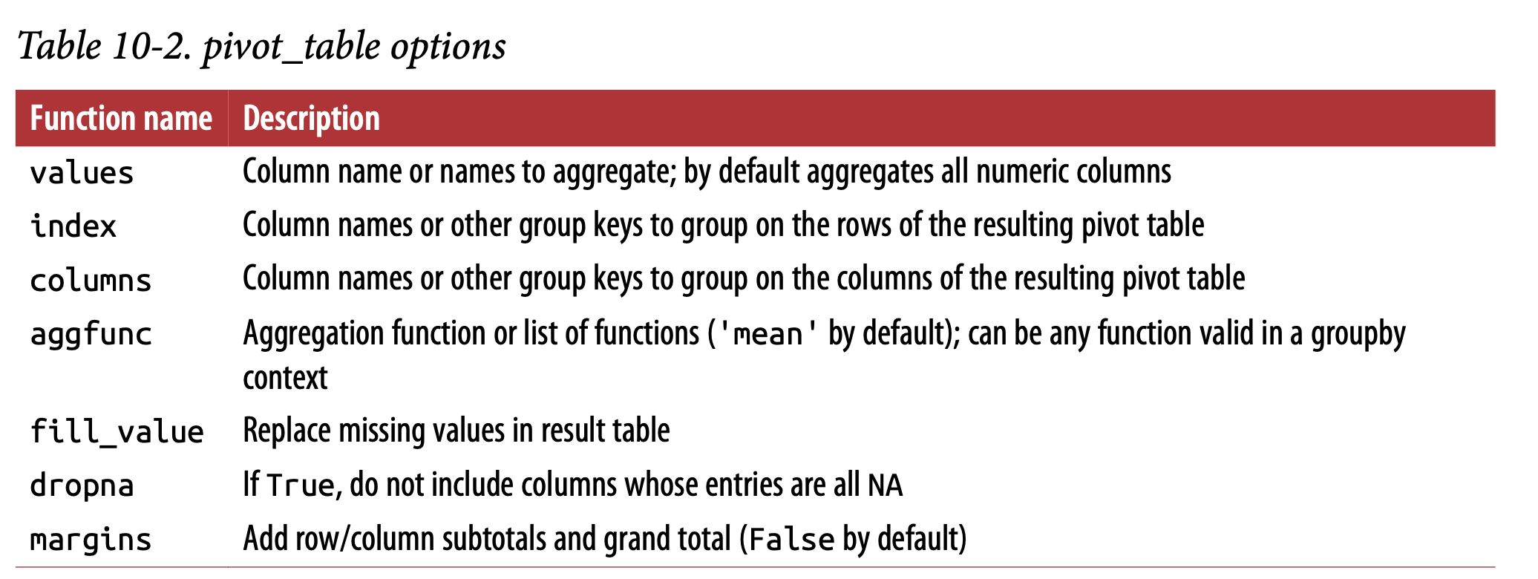
Cross-Tabulations: Crosstab
pd.crosstab(data.Nationality, data.Handedness, margins=True)

pd.crosstab([tips.time, tips.day], tips.smoker, margins=True)



